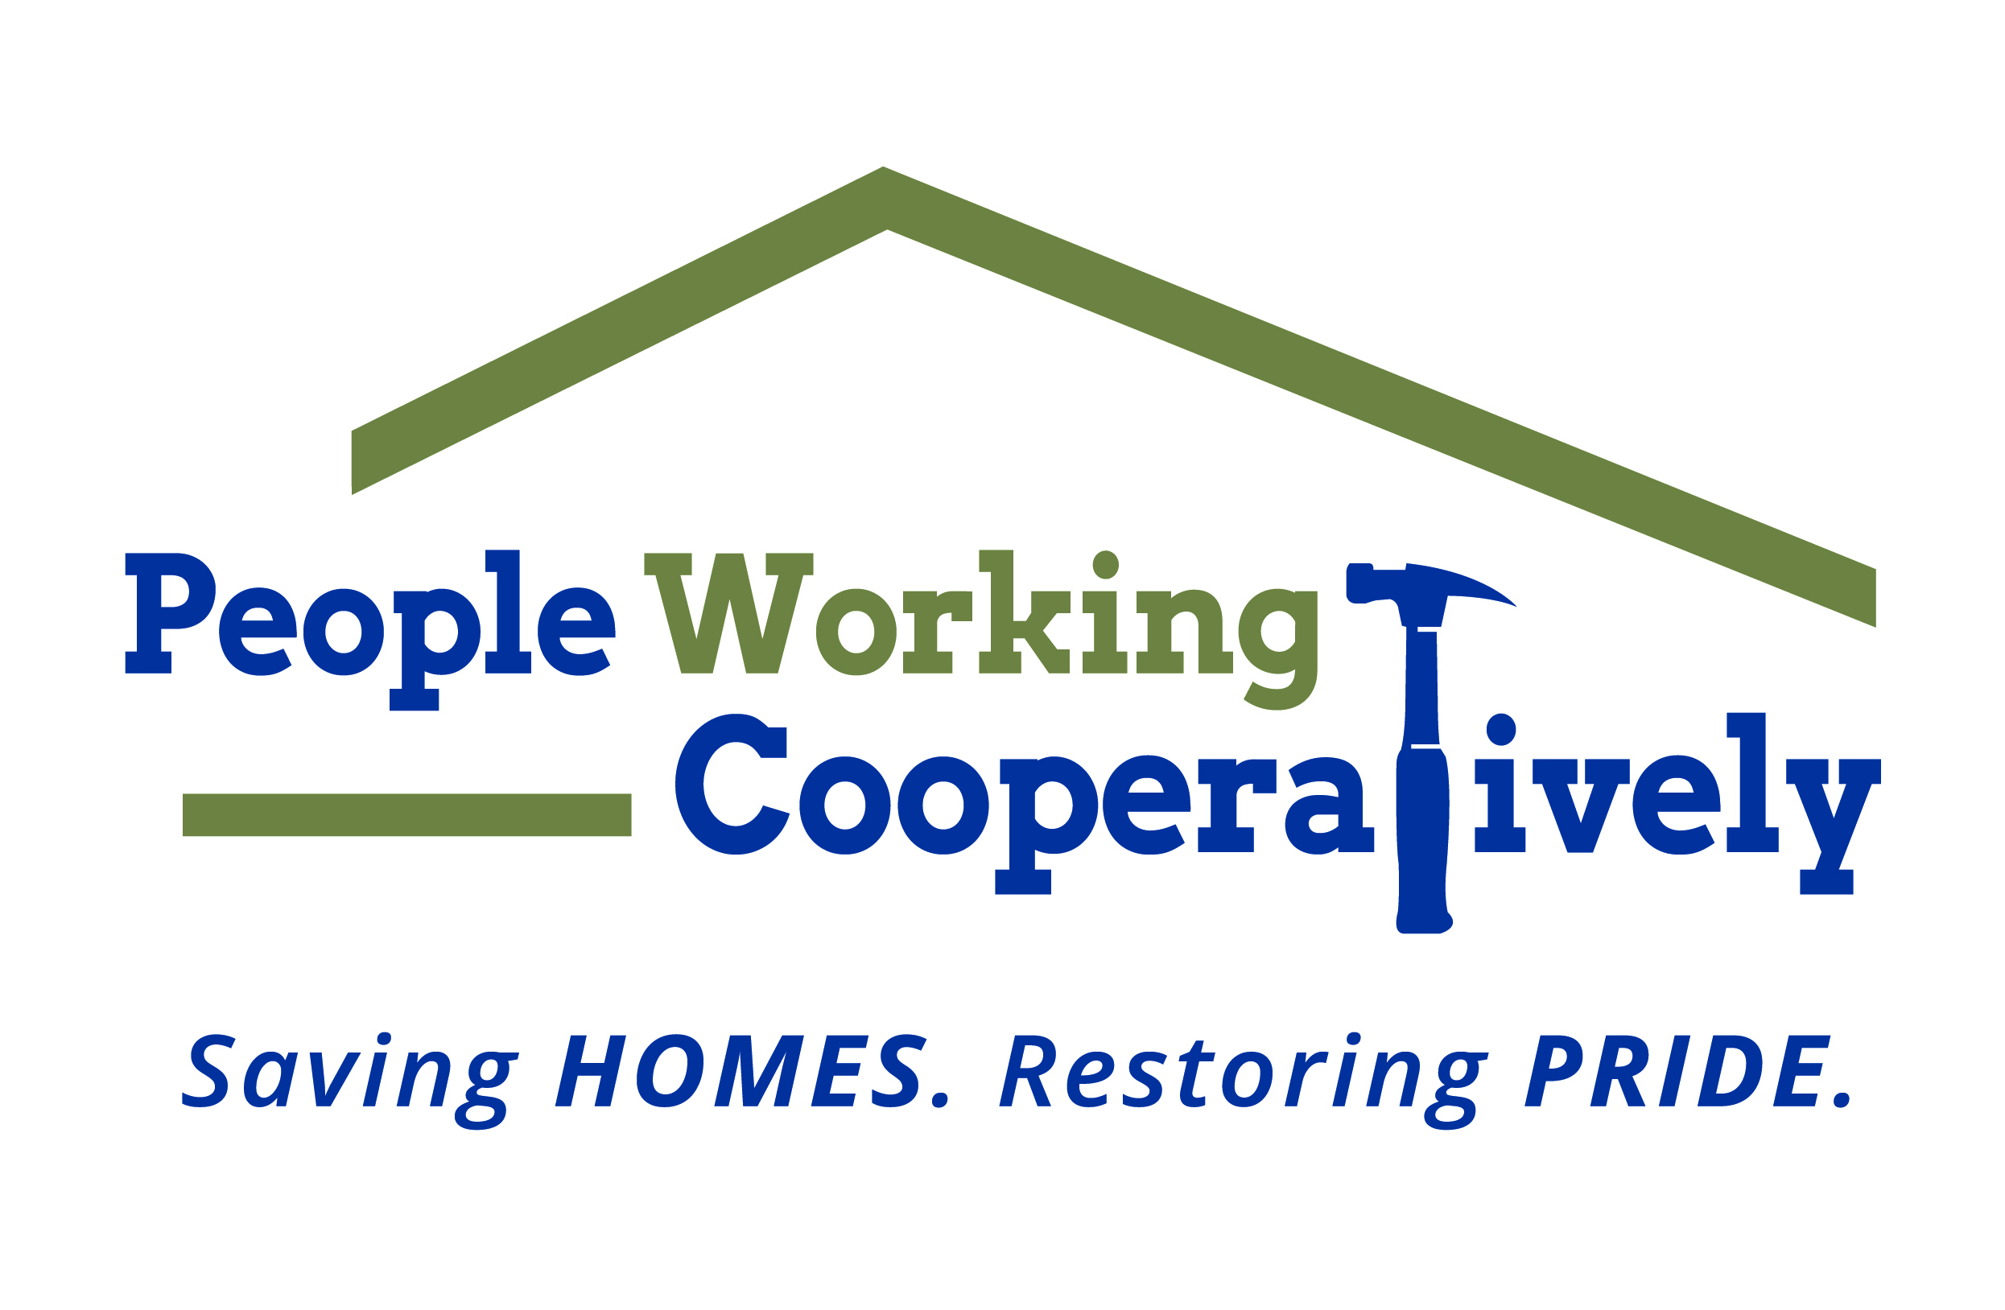
FOR IMMEDIATE RELEASE
Media Contact: Amber Potter, Scooter Media
513-236-8301 | amber@scootermediaco.com

PWC receives $30,000 grant from Truist Foundation
Grant funding to support and expand new workforce development program

CINCINNATI (April 14, 2023) – People Working Cooperatively (PWC), the Greater Cincinnati area nonprofit that provides critical home repairs, accessibility modifications and energy conservation services from professional trades staff at no cost for low-income homeowners, has received a $30,000 grant from the Truist Foundation.

The grant will support and expand PWC’s newly launched Workforce Development Program, which addresses a critical shortage of skilled workers in the construction trades and supports PWC’s ability to meet the home services needs of low-income residents of the Tri-State region.

“PWC is extremely thankful for this grant from the Truist Foundation as it will bolster our efforts with two underserved communities in both the construction industry workforce and our neighbors in need of critical home repairs,” said PWC President Jock Pitts. “Through our Workforce Development Program, we help existing and new trades staff learn the skills they need for a well-paid and meaningful career in the trades, which in turn helps improve quality of life for individuals and families across Greater Cincinnati. As demand for PWC’s services continues to grow, we are dedicated to helping to create the workforce needed to assist those throughout the 20 counties where we provide homeowners with assistance and, more importantly, ensure they maintain their safety and independence.”

PWC partnered with Allied Construction Industries, a local leader in trades’ education, to develop and launch the apprenticeship-style workforce development program. Program enrollees are paid a full salary during their training and receive one full day of classroom training each week. Additionally, program enrollees receive four days of on-the-job learning with PWC professional trades-staff as well as support from a dedicated mentor. PWC eventually expects to provide a classroom portion of the program to employees of local construction companies at reasonable rates while they provide on-the-job mentorship.

To learn more about People Working Cooperatively and who is eligible for services, visit pwchomerepairs.org or call (513) 351-7921.

# # #

About People Working Cooperatively
Incorporated in 1975, People Working Cooperatively (PWC) is a non-profit organization serving low-income, elderly, and disabled homeowners in 20 counties of southwest Ohio, Dayton, northern Kentucky and southeast Indiana. For 48 years, PWC has strengthened communities by providing professional, critical home repair, weatherization, and modification services to help residents stay safely in their homes. PWC’s staff of licensed, trained employees and dedicated corps of volunteers assist nearly 6,000 individuals in more than 3,500 homes each year. For more information, visit pwchomerepairs.org or call (513) 351-7921.

