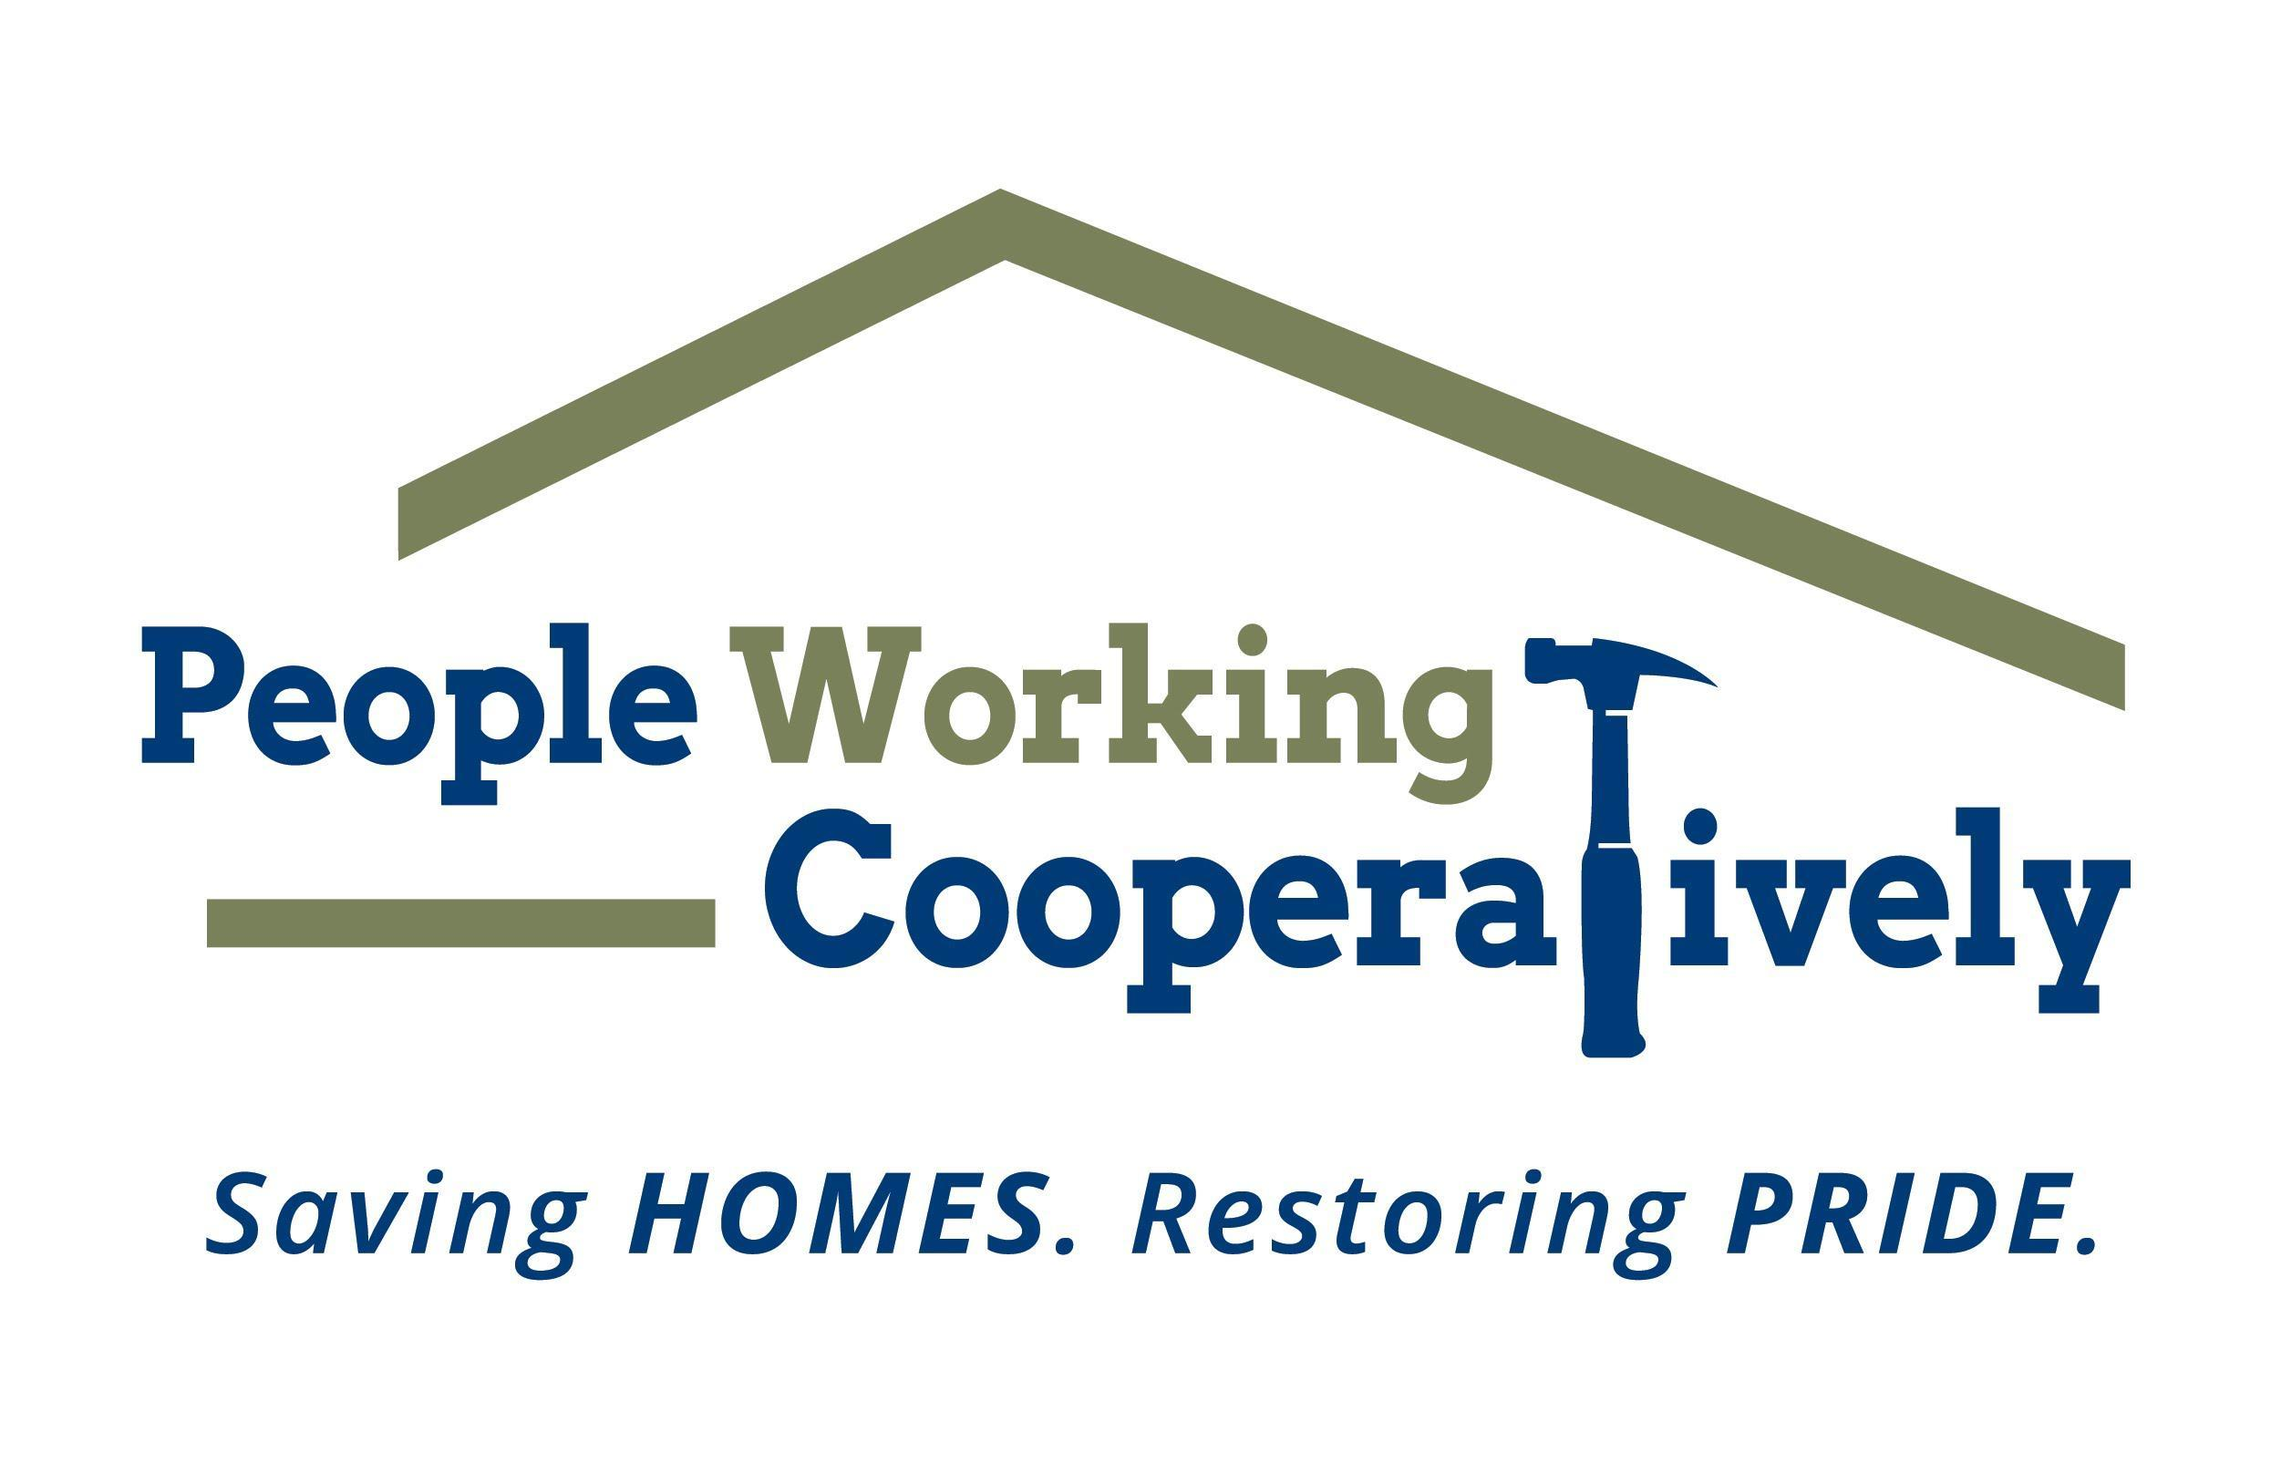

FOR IMMEDIATE RELEASE:
Media Contact: Katie Forcade
571-266-2878 | katie@scootermediaco.com

Hop to It: Registration Now Open for People Working Cooperatively and Samuel Adams Cincinnati Taproom’s Annual Homebrew Competition

CINCINNATI (Feb. 27, 2024) – People Working Cooperatively’s (PWC) Emerging Leaders Board and the Samuel Adams Cincinnati Taproom are partnering for a beer-y good time for the third annual Boards and Brews Homebrew Competition. This yearly contest brings together beer makers and beer lovers to support PWC’s mission to serve low-income, elderly, and disabled homeowners throughout the Greater Cincinnati area.

Those interested in brewing up a cold one can register for the competition now through April 5. Registration is $150 per beer entry and includes a $50 stipend for brewing ingredients. Teams are allowed to submit multiple entries but must pay the registration fee for each. Brewers will have through June 2 to brew their beer and submit it for judging. Learn more and register at PWChomerepairs.org/brew.

“We’re extremely grateful to be partnering again with Sam Adams for the Boards and Brews Homebrew Competition, which has become an annual tradition that allows us to connect and engage directly with the community while building a more diverse base of supporters,” said Jock Pitts, PWC President. “This event not only helps to financially support PWC, but also gives people a chance to learn about the impact we make in our neighborhoods so they can become more involved.”

Final judging by the Cincinnati Malt Infusers will decide who has the ‘lager’ than life brew. The winning team will be unveiled during the Boards & Brews Cornhole Tournament on June 23 at the Sam Adams Cincinnati Taproom. The winning team receives a $250 cash prize and will help brew their recipe with Sam Adams Cincinnati Taproom Head Brewer, Chris Siegman, on-site at the Cincinnati Taproom, with the opportunity to tap with their friends and family at a taproom event in August.

“We look forward to this annual competition and partnership with PWC each year,” said Keith McEly, General Manager of Sam Adams Cincinnati Taproom. “We are excited to once again celebrate the rich brewing history of Cincinnati and continue to raise awareness and support for the local community.”

Proceeds benefit PWC, allowing the organization to provide critical home repairs and mobility modifications for neighbors in need. Boards & Brews is possible thanks to the support and generosity of several sponsors, including Presenting Sponsor Samuel Adams Cincinnati Taproom.

# # #

About People Working Cooperatively
Incorporated in 1975, People Working Cooperatively (PWC) is a non-profit organization serving low-income, elderly, and disabled homeowners in 20 counties of southwest Ohio, Dayton, northern Kentucky and southeast Indiana. For 49 years, PWC has strengthened communities by providing professional, critical home repair, weatherization, and modification services to help residents stay safely in their homes. PWC’s staff of licensed, trained employees and dedicated corps of volunteers assist nearly 6,000 individuals in more than 3,500 homes each year. For more information, visit pwchomerepairs.org or call (513) 351-7921.

The PWC Emerging Leaders Board serves as an organization of young professionals and emerging community leaders committed to supporting the mission of PWC by promoting awareness and encouraging involvement through effective community action in the form of volunteer service, social fundraising and other advancement initiatives.

About The Samuel Adams Cincinnati Taproom
The Cincinnati Samuel Adams Taproom opened in November 2018 and is located near the historic Findlay Market and across the street from the Samuel Adams Brewery in Over-the-Rhine. It serves as a meeting place for beer drinkers, local Cincinnatians, and visitors alike where core, seasonal and even exclusive, experimental beers are available thanks to the proximity of the Brewery and the Taproom’s on-site research and development nano-brewery.

