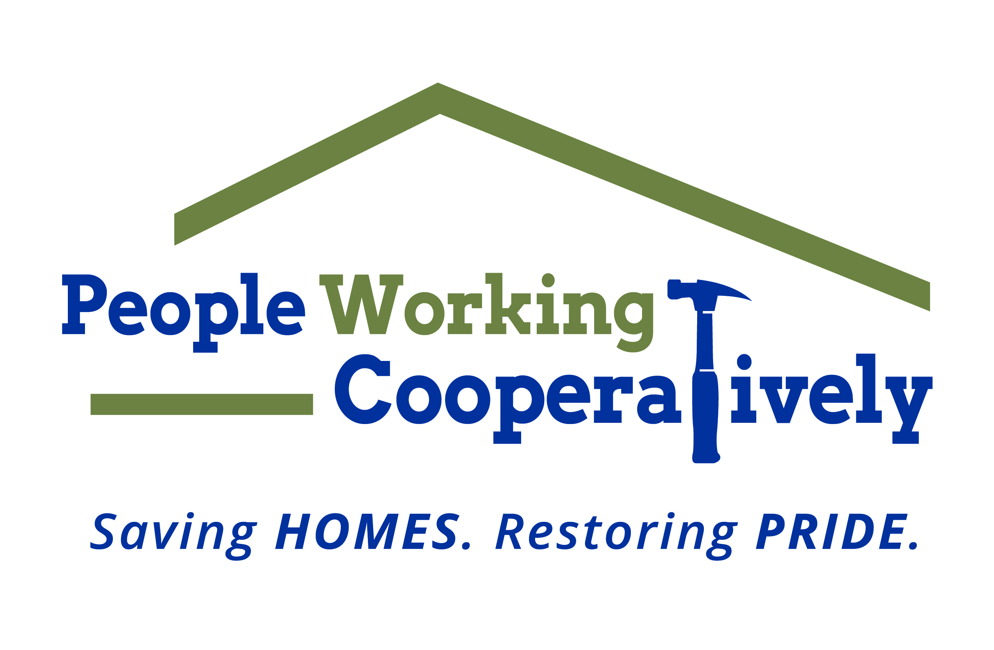
FOR IMMEDIATE RELEASE
Media Contact: Amber Potter, Scooter Media
513-236-8301 | amber@scootermediaco.com

Link: Downloadable photos
Photo credits: People Working Cooperatively

Volunteers needed for People Working Cooperatively’s annual Prepare Affair
Help neighbors in need with minor winterization tasks to keep them safe and healthy at home

CINCINNATI, Ohio (Oct. 27, 2022) – Are you looking for a way to positively impact the community and improve the quality of life for friends and neighbors in need? All it takes is a rake and some gloves to make a difference during People Working Cooperatively’s (PWC) annual fall volunteer event known as Prepare Affair.

Throughout the month of November, nearly 2,000 volunteers will provide fall cleanup services for hundreds of low-income seniors, veterans and people with disabilities throughout Cincinnati and Northern Kentucky to help prepare homes and lawns for cold weather. All skill levels are welcome to participate, and signing up is as simple as registering online. Volunteers can join forces with friends, co-workers, church groups and family members to create their own crew; or individuals can join an existing team.

“As one of the largest volunteer events in the Tri-State region, Prepare Affair is an opportunity for the community to help neighbors in need stay safe and healthy at home throughout the winter months,” said PWC President Jock Pitts. “We couldn’t help as many people as we do without the support of our volunteers. Not only will you be helping often-underserved individuals, but Prepare Affair is also a great chance to get to know new people, team build with co-workers or charity organizations and see the difference you’re making in real-time.”

Prepare Affair projects range from raking leaves and cleaning gutters to other minor winter preparation tasks that help residents keep their homes safe and livable throughout the cold-weather season. PWC will be celebrating Prepare Affair on Saturday, Nov. 19, but volunteers are invited to schedule their service on any day in November that works best for them.

Registration is available online at pwchomerepairs.org/prepare-affair. For more information, contact Brian McLaughlin, PWC Volunteer Program Manager, at 513-351-7921.

Prepare Affair is presented by The City of Cincinnati.

# # #
About People Working Cooperatively
Incorporated in 1975, People Working Cooperatively (PWC) is a non-profit organization serving low-income, elderly, and disabled homeowners in 20 counties of southwest Ohio, Dayton, northern Kentucky and southeast Indiana. For 47 years, PWC has strengthened communities by providing professional, critical home repair, weatherization, and modification services to help residents stay safely in their homes. PWC’s staff of licensed, trained employees and dedicated corps of volunteers assist nearly 6,000 individuals in more than 3,500 homes each year. For more information, visit pwchomerepairs.org or call (513) 351-7921.

