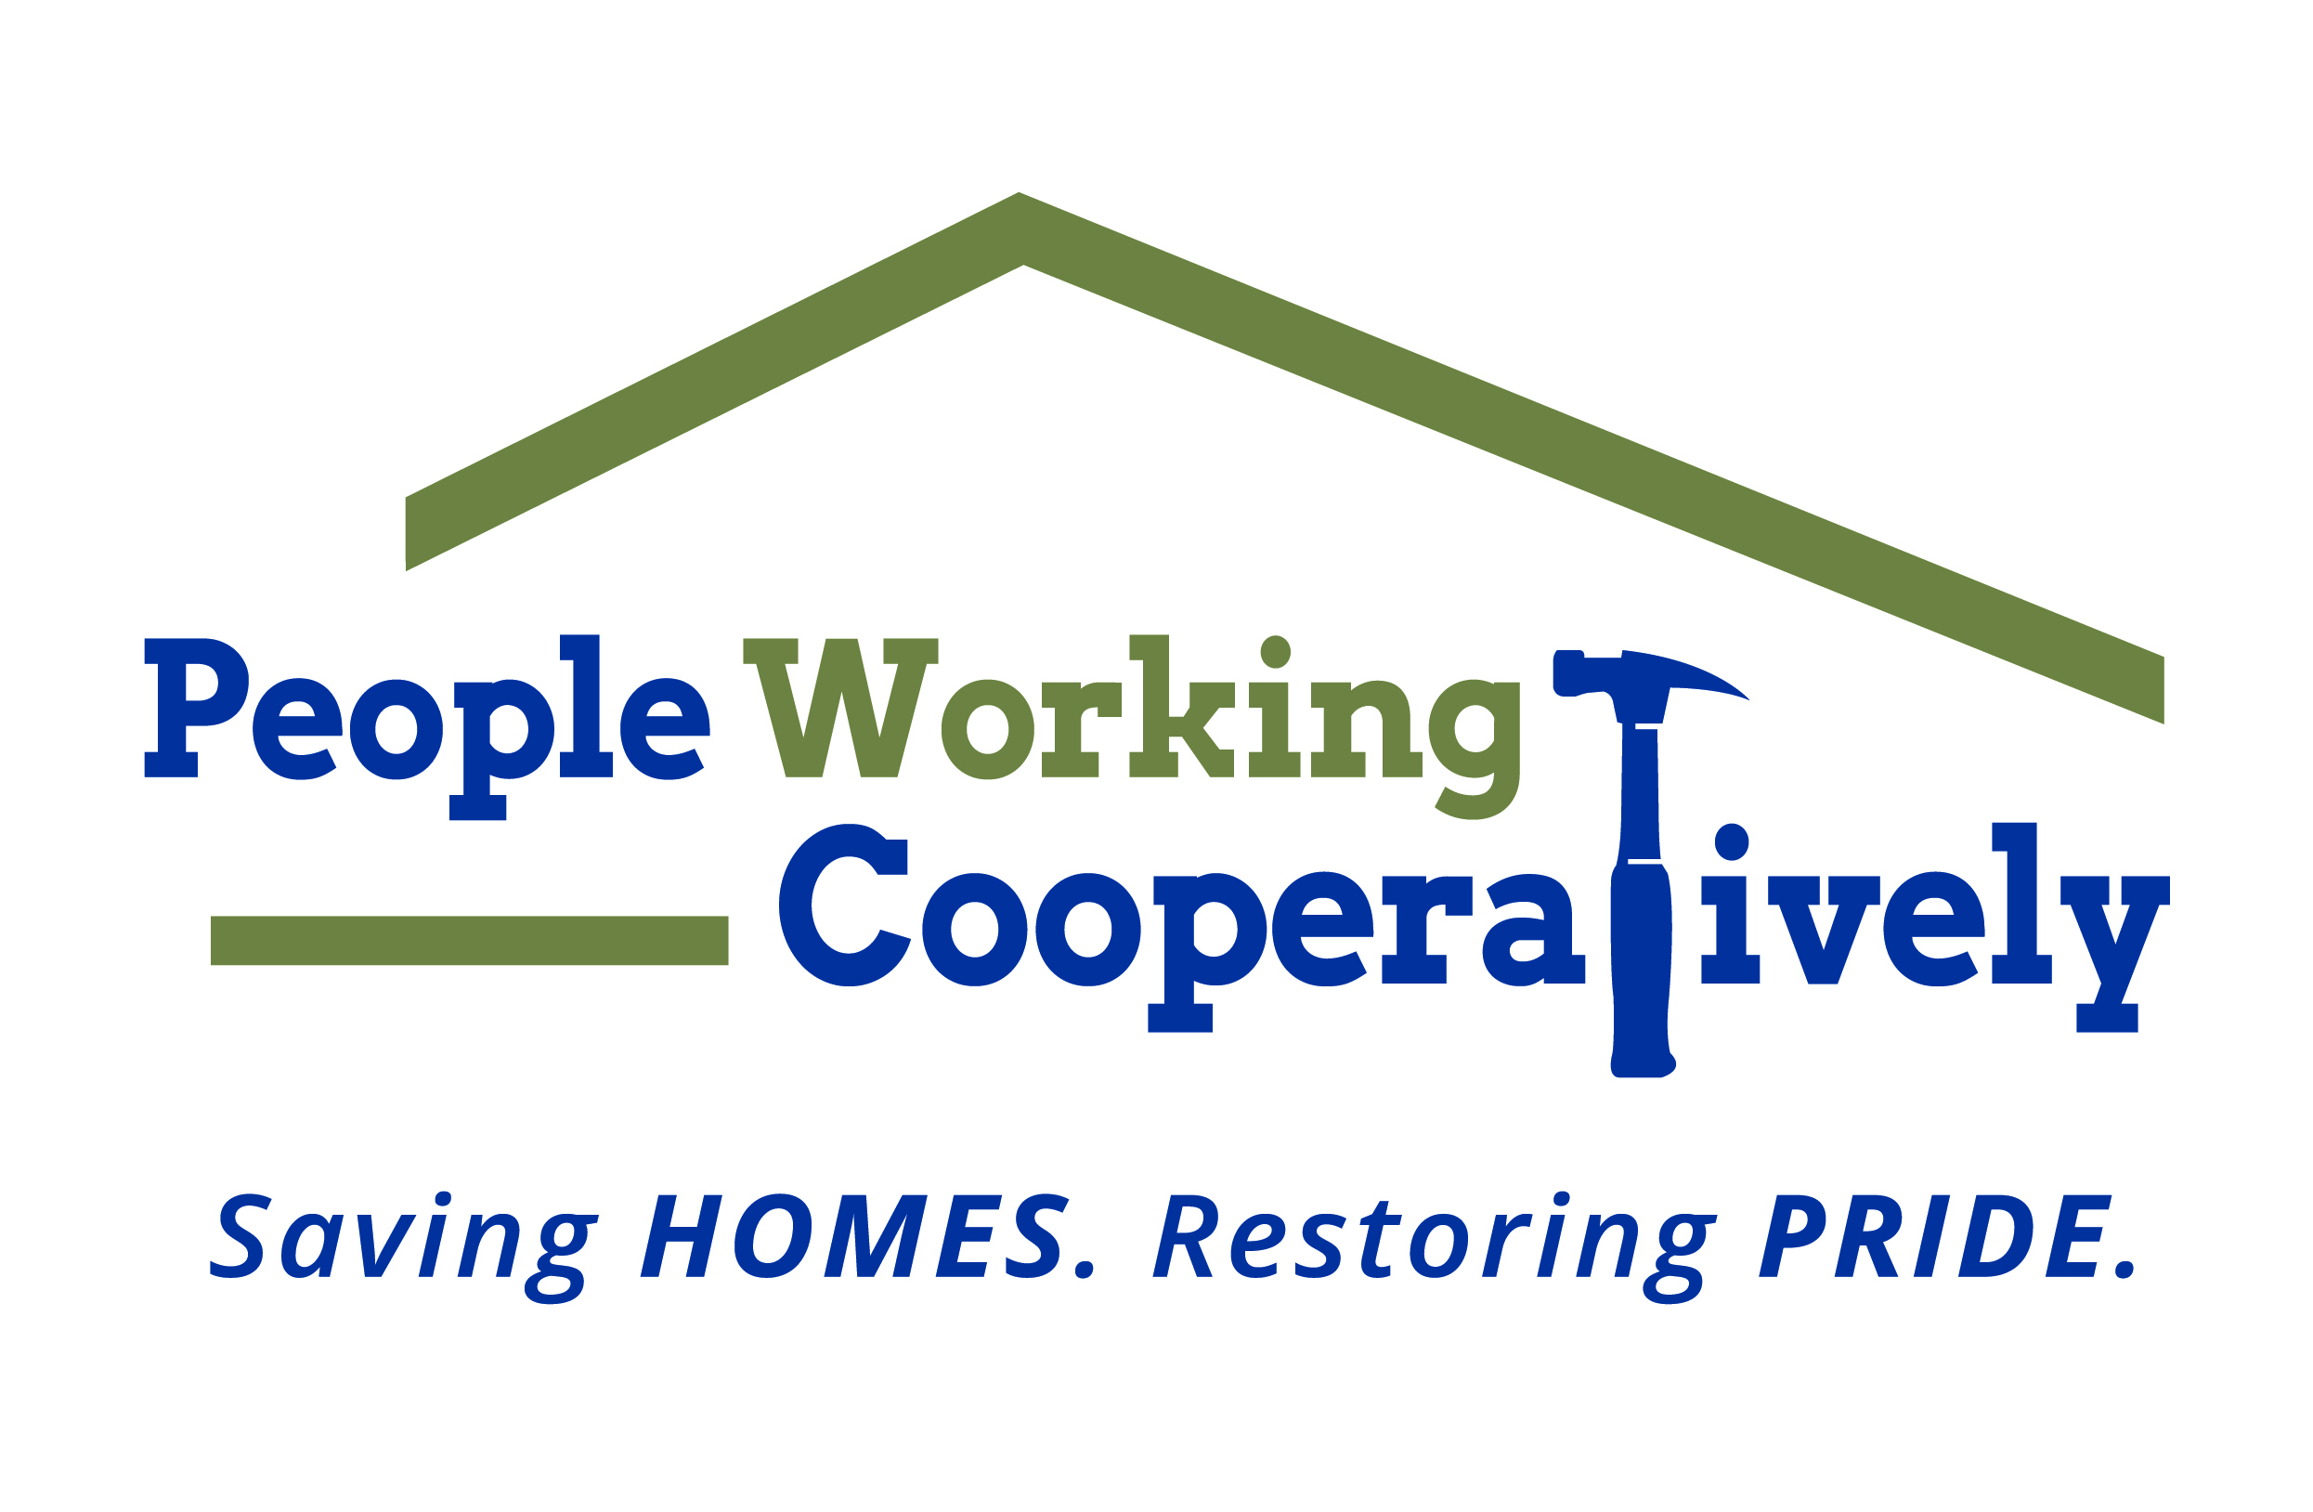
FOR IMMEDIATE RELEASE
Media Contact: Amber Potter, Scooter Media
513-236-8301 | amber@scootermediaco.com

Click here for headshots.

People Working Cooperatively announces new board chair, additional board updates

CINCINNATI (Jan. 27, 2023) – People Working Cooperatively (PWC), the Greater Cincinnati/Northern Kentucky nonprofit dedicated to providing critical home repairs, energy conservation and accessibility modifications for low-income, elderly and homeowners with disabilities, is pleased to announce that PWC Board of Directors member Matt Buddenberg has been named the new board chair.

“We look forward to the support and guidance the Board of Directors will continue to provide under the leadership of Matt Buddenberg as the new board chair,” said Jock Pitts, PWC President. “The board’s hard work allows PWC to continue to serve our neighbors in need each year.”

Tom Colvin, Cincinnati area president for Gallagher Benefit Services, will be handing over the reins as board chair to Buddenberg who is the Principal Estimator at Messer Construction Co. Colvin will continue to serve as a board member.

Buddenberg was first elected to the PWC Board in April 2018 and most recently held the title of vice-chairperson. He is involved with the organization’s ToolBelt Ball committee and has volunteered for the annual Prepare Affair and Repair Affair events over the years. Buddenberg is a graduate of Northern Kentucky University where he earned a bachelor’s degree in construction management. He also holds a Kentucky Society of Healthcare Engineering certification.

Additionally, immediate past board chair Rick Zoller, has retired from the PWC board. Zoller, who is also retired from his role as Operations Vice President at Messer Construction, served on the board for more than 15 years.

PWC performs critical home repairs and modifications for low-income homeowners – many of whom are elderly, veterans, single parents or grandparents raising children, and individuals with disabilities – in communities throughout Greater Cincinnati to help them stay safe and healthy at home. The organization is often the only resource for these underserved community members and is committed to providing its professional expertise and services to help these local residents remain in their homes.

To learn more about People Working Cooperatively and how you can support those in need in your community, visit www.pwchomerepairs.org or call (513) 351-7921.

# # #

About People Working Cooperatively
Incorporated in 1975, People Working Cooperatively (PWC) is a non-profit organization serving low-income, elderly, and disabled homeowners in 20 counties of southwest Ohio, Dayton, northern Kentucky and southeast Indiana. For 48 years, PWC has strengthened communities by providing professional, critical home repair, weatherization, and modification services to help residents stay safely in their homes. PWC’s staff of licensed, trained employees and dedicated corps of volunteers assist nearly 6,000 individuals in more than 3,500 homes each year. For more information, visit pwchomerepairs.org or call (513) 351-7921.

