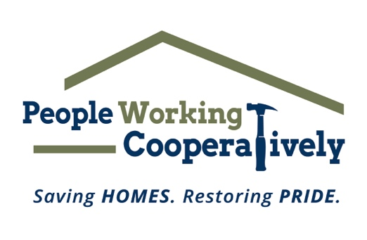
FOR IMMEDIATE RELEASE
Media Contact: Katie Forcade, Scooter Media
571-266-2878 | Katie@scootermediaco.com

Link to: Downloadable photos
Photo credit: People Working Cooperatively

People Working Cooperatively on a Mission to Ramp It Up for Veterans
Campaign helps aging veterans with critical home repairs, accessibility modifications

CINCINNATI (Sept. 12, 2023) – People Working Cooperatively (PWC) kicked off its 12th annual Ramp It Up for Veterans campaign on Patriot Day, Sept. 11, to assist low-income and disabled veterans throughout Greater Cincinnati and Northern Kentucky.

The brave men and women of the U.S. Armed Forces have risked their lives so we can have our freedoms. Many veterans are now aging and living with disabilities. They find themselves in need of critical home repairs and accessibility modifications that they can’t afford.

PWC has provided services for more than 6,500 households of veterans or their surviving spouses and is committed to this program because the need continues to escalate as local veterans continue to age and need more support.

“Our veteran community not only deserves respect and reverence for serving our country, but they also deserve a home in which they can reside safely, and which is accessible for them no matter their abilities and needs,” said PWC President Jock Pitts. “Ramp It Up for Veterans is our opportunity to serve these veterans as they served all of us. This campaign is aimed at eliminating our waitlist for services and ensuring that all of our veterans are taken care of.”

Ramp It Up for Veterans will run through the end of 2023. All donations are critical in helping PWC meet the rising number of veterans in need.

PWC performs critical home repairs and modifications for low-income, elderly and homeowners with disabilities. The organization is often the only resource for these underserved community members and is committed to providing its professional expertise and services to help these local residents remain in their homes.

To learn more about PWC and the Ramp It Up for Veterans campaign, visit www.pwchomerepairs.org/veterans or call (513) 351-7921.

# # #

About People Working Cooperatively
Incorporated in 1975, People Working Cooperatively (PWC) is a non-profit organization serving low-income, elderly, and disabled homeowners in 20 counties of southwest Ohio, Dayton, northern Kentucky, and southeast Indiana. For more than 48 years, PWC has strengthened communities by providing professional, critical home repair, weatherization, and modification services to help residents stay safely in their homes. PWC’s staff of licensed, trained employees and dedicated corps of volunteers assist nearly 6,000 individuals in more than 3,500 homes each year. For more information, visit pwchomerepairs.org or call (513) 351-7921.

