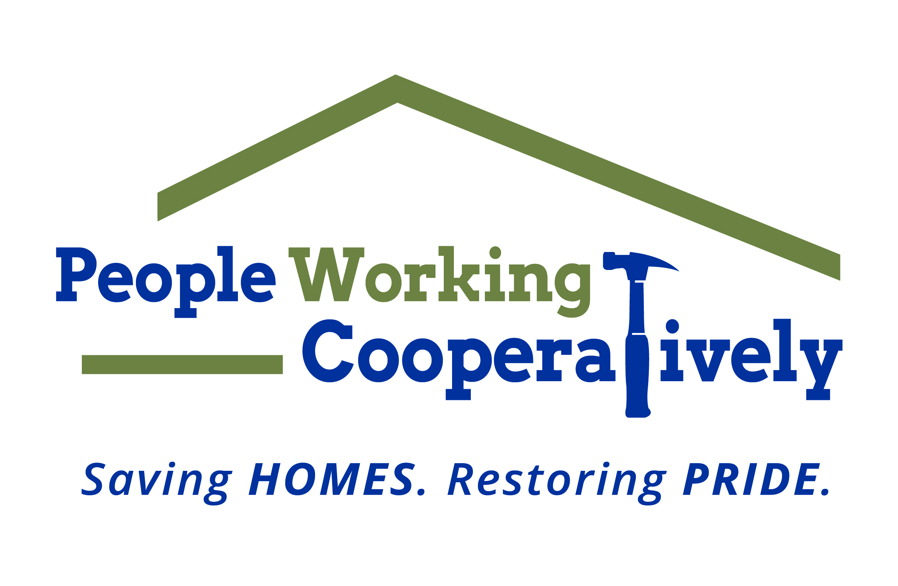
FOR IMMEDIATE RELEASE
Media Contact: Amber Potter, Scooter Media
513-236-8301 | amber@scootermediaco.com

Click here for photos from past Repair Affair events.
Photos courtesy of People Working Cooperatively.

People Working Cooperatively seeks volunteers for
41st annual Repair Affair in June
Signature volunteer event will provide home maintenance services for neighbors in need

CINCINNATI (May 15, 2023) – People Working Cooperatively (PWC), a nonprofit that provides critical home repair, weatherization, and accessibility modification services for low-income homeowners throughout Greater Cincinnati, is seeking volunteers for its Repair Affair in June.

Repair Affair is PWC’s annual volunteer event that provides low-income seniors, people with disabilities and veterans with home repairs and maintenance tasks they need to keep their home safe. During last year’s Repair Affair, more than 450 volunteers donated 1,850 hours to complete projects at 50 households across Greater Cincinnati.

“Repair Affair is the perfect opportunity to get outside and spend a morning doing good in your community,” said Brian McLaughlin, PWC Volunteer Program Manager. “The hundreds of volunteers who participate each year make a real impact in helping us provide services for the neighbors in need currently on our waiting list.”

The main participation date for Repair Affair is Saturday, June 10, which includes a post-event celebration with free food and fun for all volunteers. However, volunteer groups can sign up to participate in Repair Affair any day in June that works best for them.

PWC will provide participants with all materials and handle debris disposal. Volunteers are asked to commit to at least four hours of service and will be matched with a project that fits the skills and preferences of their group.

Common projects completed as part of Repair Affair include:

- Installing handrails
- Repairing concrete walkways
- Repairing decks and steps
- Painting and landscaping
- Repairing drywall
- Performing other needed home maintenance tasks

Many of PWC’s clients are elderly, veterans, single parents or grandparents raising children, and individuals with disabilities living on a fixed income. The organization is often the only resource for these underserved community members, and it is committed to providing professional expertise and services to help these local residents remain living independently, safely and healthily in their homes.

Volunteers can register online at pwchomerepairs.org/repair-affair or contact Brian McLaughlin, PWC’s Volunteer Program Manager, at mclaughlinb@pwchomerepairs.org.

Repair Affair is presented by the City of Cincinnati, along with support from Major Sponsor BSI Engineering, Supporting Sponsors Danis Construction and Hixson, and special thanks to LaRosa’s.

# # #
About People Working Cooperatively
Incorporated in 1975, People Working Cooperatively (PWC) is a non-profit organization serving low-income, elderly, and disabled homeowners in 20 counties of southwest Ohio, Dayton, northern Kentucky and southeast Indiana. For 48 years, PWC has strengthened communities by providing professional, critical home repair, weatherization, and modification services to help residents stay safely in their homes. PWC’s staff of licensed, trained employees and dedicated corps of volunteers assist nearly 6,000 individuals in more than 3,500 homes each year. For more information, visit pwchomerepairs.org or call (513) 351-7921.

