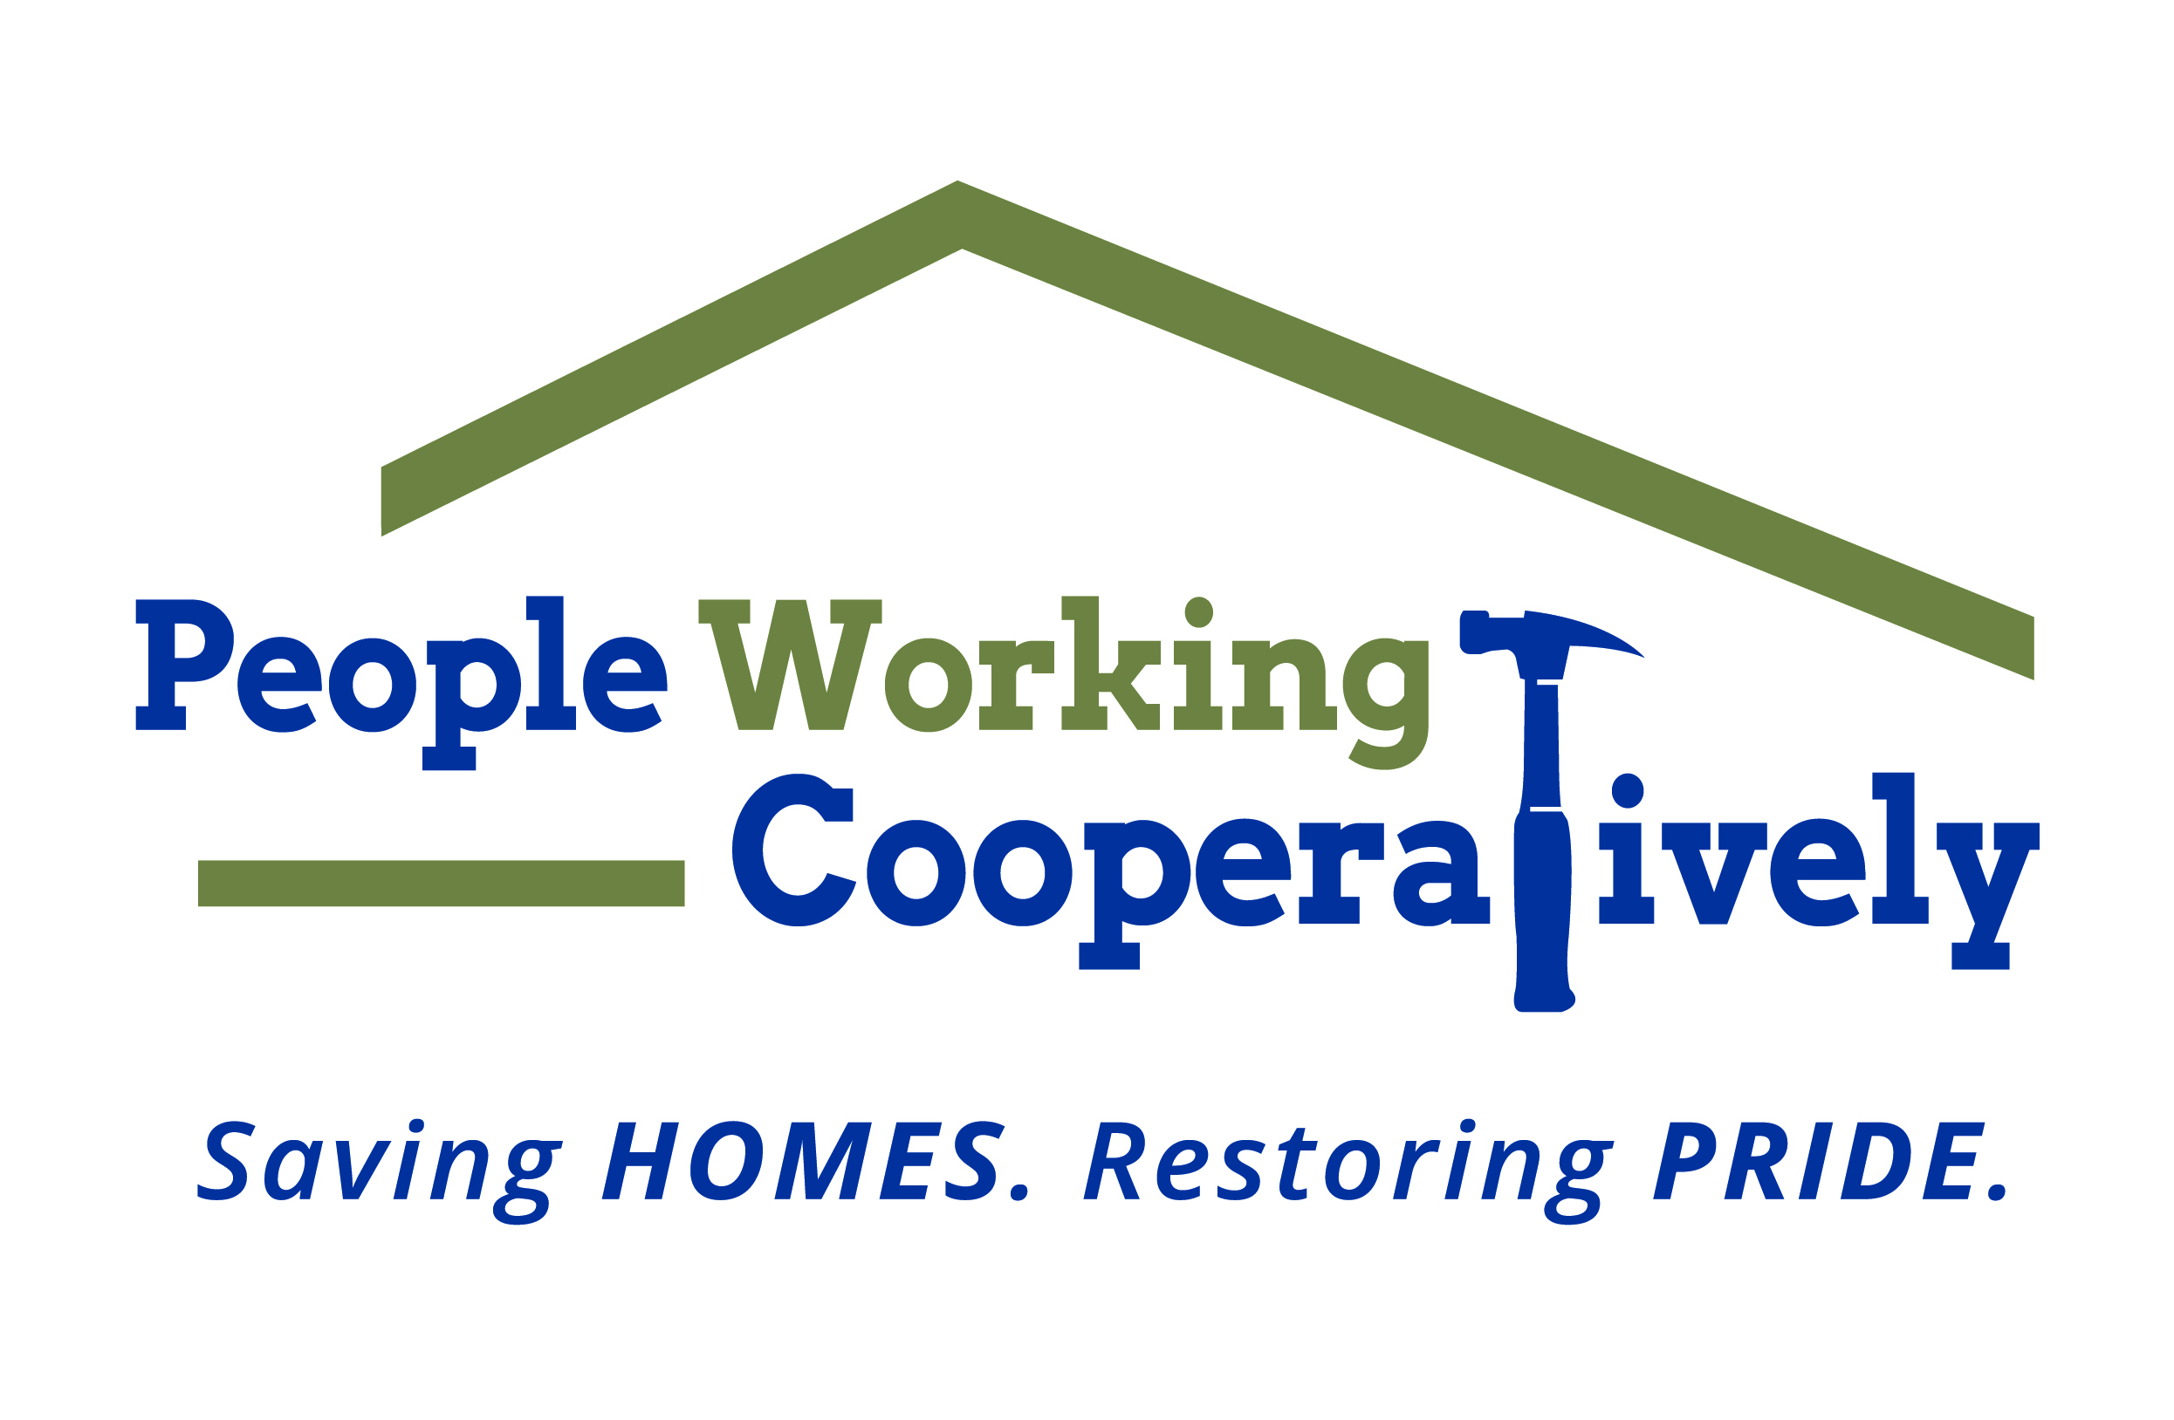
FOR IMMEDIATE RELEASE
Media Contact: Amber Potter, Scooter Media
513-236-8301 | amber@scootermediaco.com

Link to: Downloadable photos
Photo credit: People Working Cooperatively

People Working Cooperatively ready to Ramp It Up for Veterans
Campaign helps aging veterans with critical home repairs, modifications

CINCINNATI, Ohio (Nov. 11, 2022) – They risked their lives to protect our freedoms. Now it’s our turn to assist veterans who are aging or living with a disability. Too many veterans find themselves in need of critical home repairs and accessibility modifications that they simply can’t afford. They deserve a helping hand with those needs in gratitude for the sacrifices they made for our country.

People Working Cooperatively (PWC) kicks off its annual Ramp It Up for Veterans campaign on Veterans Day, Nov. 11, continuing a tradition that has provided services for more than 6,200 veterans, surviving spouses or children of veterans.

James, a native of Covington, Kentucky, is an Army veteran who served three tours in Vietnam. He recently underwent a leg amputation in addition to being on dialysis, which made maneuvering around his home challenging. PWC stepped in to provide repairs like replacing handrails on the front porch and expanding the railing to the driveway to help with mobility issues. There are many more veterans like James who need our help.

“Our veteran community is just that – a part of our community that not only deserves respect and reverence for serving our country, but a group that also deserves a home that is not in disrepair or outright hazardous to their health,” said Ron Henlein, PWC’s Director of Corporate and Community Partnerships. “Ramp It Up for Veterans is our opportunity to serve these veterans as they served all of us. We have nearly 400 veterans on our waiting list. This campaign is aimed at eliminating that wait list and ensuring that all of our veterans are taken care of.”

Consider these statistics:
- There are more than 175,000 veterans within PWC’s 20-county service territory.
- In Hamilton County, there are 38,000 veterans and 53% of them are 65 years of age or older – 25% of those are over 75 years old.
- One out of three veterans over 65 has a disability.
- More than 2,000 veterans in Hamilton County are living below the poverty level.

Ramp It Up for Veterans will run through the end of 2022. All donations are critical in helping PWC meet the rising number of veterans in need.

To learn more about PWC and the Ramp It Up for Veterans campaign, visit www.pwchomerepairs.org/veterans or call Ron Henlein at (513) 482-5111.

# # #

About People Working Cooperatively
Incorporated in 1975, People Working Cooperatively (PWC) is a non-profit organization serving low-income, elderly, and disabled homeowners in 20 counties of southwest Ohio, Dayton, northern Kentucky and southeast Indiana. For 47 years, PWC has strengthened communities by providing professional, critical home repair, weatherization, and modification services to help residents stay safely in their homes. PWC’s staff of licensed, trained employees and dedicated corps of volunteers assist nearly 6,000 individuals in more than 3,500 homes each year. For more information, visit pwchomerepairs.org or call (513) 351-7921.

