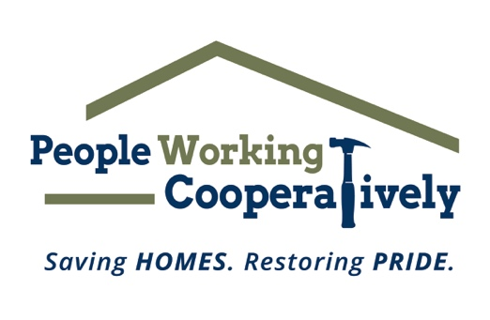
FOR IMMEDIATE RELEASE
Media Contact: Amber Potter, Scooter Media
(513) 236-8301 | amber@scootermediaco.com

Click here for Lyndy Rohe’s headshot.
Photo courtesy of People Working Cooperatively.

People Working Cooperatively Announces New Director of Major Gifts
Lyndy Rohe, former Director of Development for the National Military Family Association, joins the PWC team

CINCINNATI (August 16, 2023) – People Working Cooperatively (PWC), the Greater Cincinnati/Northern Kentucky nonprofit dedicated to providing critical home repairs, energy conservation and accessibility modifications for low-income residents, is proud to announce the addition of Lyndy Rohe to its team as Director of Major Gifts.

Rohe most recently served as the Director of Development for the National Military Family Association (NMFA), raising millions of dollars for the organization's programs and advocacy. While keeping the focus on relationships and communication and using innovative and diverse fundraising strategies, she and her team worked to inspire and connect donors and partners to NMFA's mission to strengthen and protect military families.

“Lyndy’s ability to build strong, long-lasting relationships with supporters and her understanding of the importance in showing donors how their gifts directly impact members of the community will be such a strong asset for People Working Cooperatively,” said PWC President Jock Pitts. “For an organization that has been helping neighbors in need for 48 years, we also look forward to a fresh perspective and innovative ways to fundraise so that we can continue to fulfill our mission for many more years to come.”

Rohe is a graduate of North Dakota State University with a B.S. in Political Science with a focus on Pre-Law. She is currently stationed in Ohio with her husband and four children, where she is actively involved in community efforts to support the local military population, coaches women’s lacrosse, and is an active member of several professional organizations.

PWC performs critical home repairs and modifications for low-income, elderly and homeowners with disabilities. The organization is often the only resource for these underserved community members and is committed to providing its professional expertise and services to help these local residents remain in their homes.

To learn more about People Working Cooperatively and how you can support those in need in your community, visit www.pwchomerepairs.org, email info@pwchomerepairs.org or call (513) 351-7921.

# # #

About People Working Cooperatively
Incorporated in 1975, People Working Cooperatively (PWC) is a non-profit organization serving low-income, elderly, and disabled homeowners in 20 counties of southwest Ohio, Dayton, northern Kentucky and southeast Indiana. For 48 years, PWC has strengthened communities by providing professional, critical home repair, weatherization, and modification services to help residents stay safely in their homes. PWC’s staff of licensed, trained employees and dedicated corps of volunteers assist nearly 6,000 individuals in more than 3,500 homes each year. For more information, visit pwchomerepairs.org or call (513) 351-7921.

