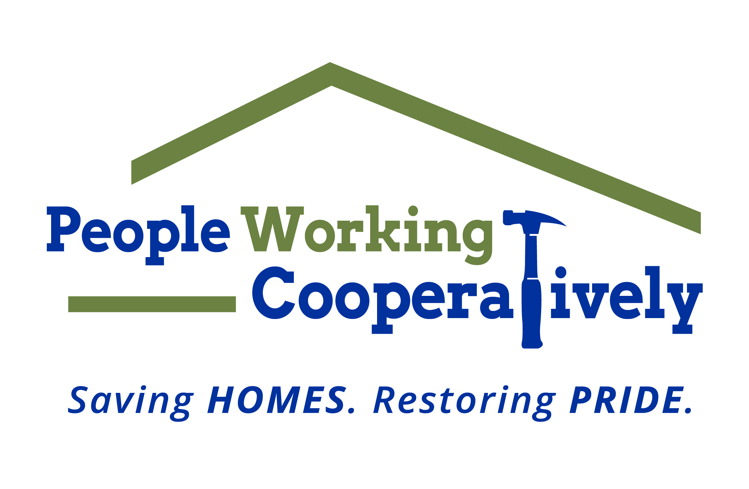
FOR IMMEDIATE RELEASE
Media Contact: Amber Potter, Scooter Media
513-236-8301 | amber@scootermediaco.com

Click here for downloadable images.

People Working Cooperatively offers chance to win full
W.L. Weller Series of bourbon
Tickets now on sale to win six bottles, valued at $2,500, to benefit programs and services for low-income neighbors in need

CINCINNATI (April 24, 2023) – People Working Cooperatively (PWC), has announced tickets are on sale now for the chance to win a full series of rare W.L. Weller Bourbon as part of a raffle to benefit the organization’s programs and services.

PWC performs critical home repairs and modifications for low-income homeowners – many of whom are elderly, veterans, single parents or grandparents raising children, and individuals with disabilities – in communities throughout Greater Cincinnati to help them stay safe and healthy at home. The organization is often the only resource for these underserved community members and is committed to providing its professional expertise and services to help these local homeowners remain in their residences.

“This region takes pride in its Northern Kentucky bourbon heritage as much as People Working Cooperatively takes pride in being able to help our friends and neighbors with the critical repairs and services needed to keep them safe in their homes,” said Jock Pitts, PWC President. “This raffle offers the public a chance to champion and celebrate both with he opportunity to support a great cause and take home some fantastic bourbon.”

Sponsored by C-Forward Information Technologies, the raffle features six bottles of Weller bourbon valued collectively at $2,500. Only 1,000 tickets will be sold for the raffle, which will also award a Buffalo Trace Starter Pack to the second-place winner. Individuals must be 21 or older to purchase tickets, which are on sale now for $50 each through May 3 (or until sold out) at www.pwchomerepairs.org/bourbon-raffle.

The W.L. Weller Bourbon Series features:

- W.L. Weller Special Reserve
- W.L. Weller Aged 12 Years
- W.L. Weller C.Y.P.B. (Craft Your Perfect Bourbon)
- W.L. Weller Single Barrel
- W.L. Weller Full Proof
- W.L. Weller Antique 107

The Buffalo Trace Starter Pack features:

- Buffalo Trace Bourbon
- Eagle Rare 10 Year
- E.H. Taylor Small Batch
- Weller Special Reserve
- Weller Antique 107

The raffle winner will be drawn and contacted on Monday, May 8. Winners are responsible for arranging pickup of prizes from PWC at 4612 Paddock Road, Cincinnati, OH. All proceeds from the raffle will further PWC’s efforts to help low-income homeowners stay safe and healthy at home.

To learn more about People Working Cooperatively and how you can support those in need in your community, visit www.pwchomerepairs.org or call (513) 351-7921.

# # #

About People Working Cooperatively
Incorporated in 1975, People Working Cooperatively (PWC) is a non-profit organization serving low-income, elderly, and disabled homeowners in 20 counties of southwest Ohio, Dayton, northern Kentucky and southeast Indiana. For 48 years, PWC has strengthened communities by providing professional, critical home repair, weatherization, and modification services to help residents stay safely in their homes. PWC’s staff of licensed, trained employees and dedicated corps of volunteers assist nearly 6,000 individuals in more than 3,500 homes each year. For more information, visit pwchomerepairs.org or call (513) 351-7921.

