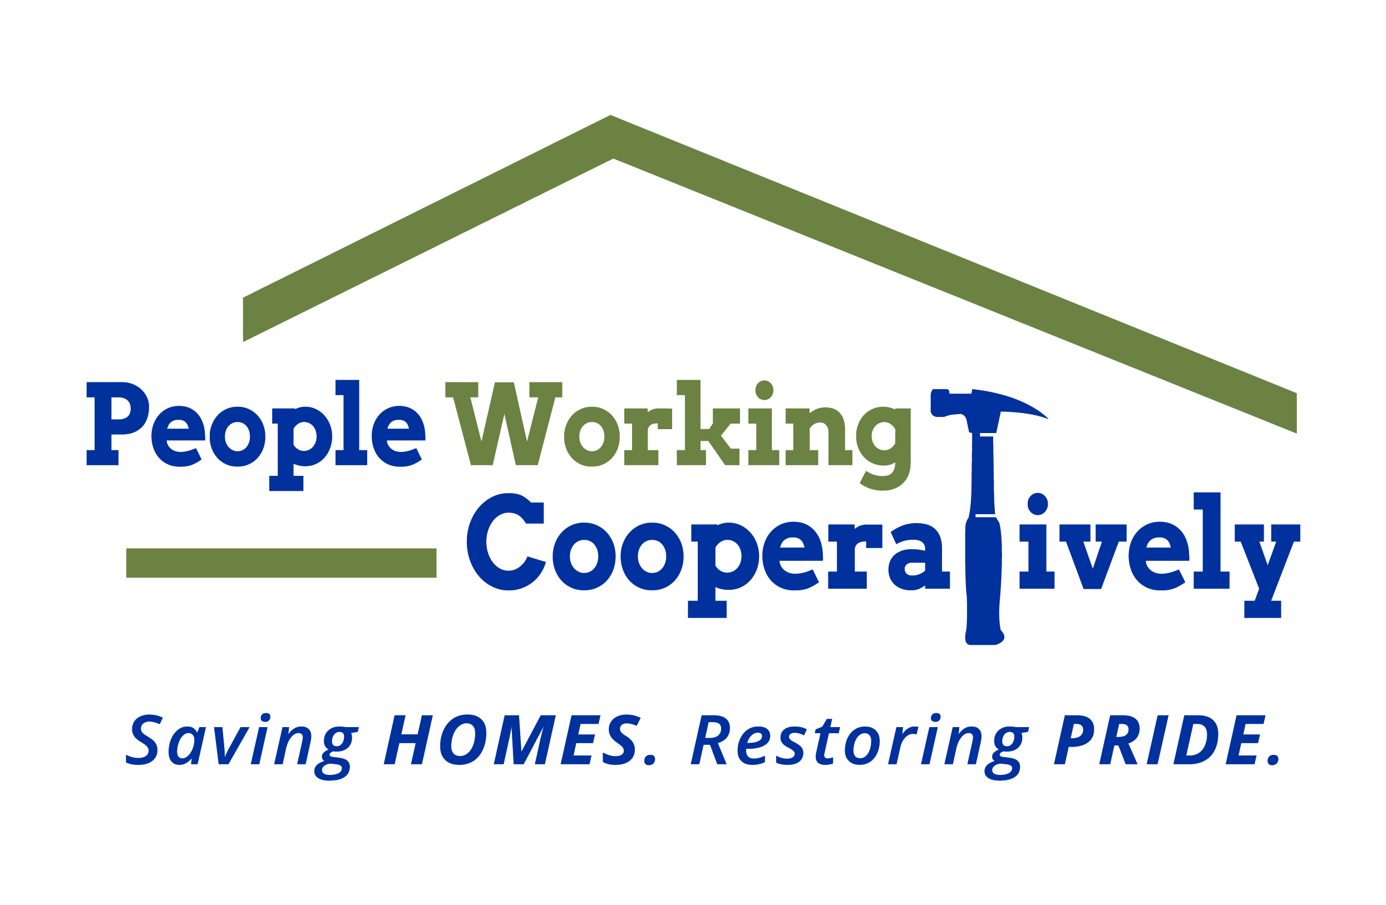
FOR IMMEDIATE RELEASE
Media Contact: Amber Potter, Scooter Media
513-236-8301 | amber@scootermediaco.com

People Working Cooperatively honors volunteers at
Annual Recognition Celebration, Sept. 27

CINCINNATI (Sept. 12, 2022) – People Working Cooperatively (PWC) is hosting its Annual Recognition Celebration at Newport Aquarium on Tuesday, Sept. 27, to honor individuals in the community that have made an impact on its mission to save homes and restore pride.

PWC provides professional, critical home repair, weatherization and accessibility modification services for low-income homeowners throughout Greater Cincinnati. Many of PWC’s clients are elderly, veterans, single parents or grandparents raising children, and individuals with disabilities living on a fixed income. With the need for services outweighing resources, PWC relies on the support of its dedicated corps of volunteers, in addition to its staff of licensed and trained employees, to help these local residents remain living independently.

“The work we do each and every day allows our neighbors to stay healthy and safe in their own homes,” said Jock Pitts, PWC President. “This event is about honoring those in the community that give of their time and skills to help us to achieve and further our mission — including our staff, volunteers, local businesses and like-minded organizations. We are truly thankful for their dedication and support.”

The 2022 award recipients are:
- Chairman’s Award: Ohio Department of Health
- Dick Castellini Philanthropy Award: Bill & Helene Sedwick
- Friends of PWC Award: Susan Johnson and Decal Impressions
- Volunteer of the Year Award: John Hart
- PWC Employee of the Year Award: Kevin Hicks
- Dan Ober Volunteer Hall of Fame 2022 Inductees:
  - Greg Bishop
  - Cynthia Blocksom
  - Steve Herbold
  - Kevin Hicks
  - Teresa Huxel
  - Rick Kramer
  - Jim Ramsey
  - Bill Sedwick
  - Greg Shumate

Doors open at 11:30 a.m., and the program begins at Noon. Individual reservations are $45, and a table sponsorship is $500. Tickets are available for purchase online through Sept. 19.

For more information about the Annual Recognition Celebration and People Working Cooperatively, visit pwchomerepairs.org or call (513) 351-7921.

# # #

About People Working Cooperatively
Incorporated in 1975, People Working Cooperatively (PWC) is a non-profit organization serving low-income, elderly, and disabled homeowners in 21 counties of southwest Ohio, Dayton, northern Kentucky and southeast Indiana. PWC strengthens communities by providing professional, critical home repair, weatherization, and modification services to help residents stay safely in their homes. In the last 47 years, PWC’s staff of licensed, trained employees and dedicated corps of 3,000 volunteers have assisted more than 320,000 individuals. For more information, visit pwchomerepairs.org or call (513) 351-7921.

