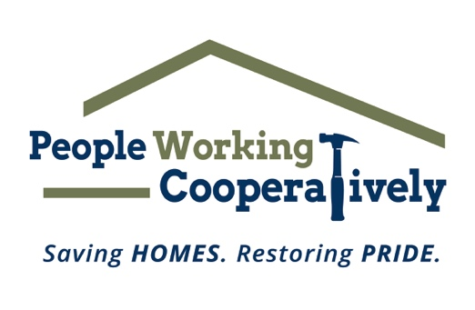

FOR IMMEDIATE RELEASE
Media Contact: Katie Forcade, Scooter Media
571-266-2878 | katie@scootermediaco.com

People Working Cooperatively receives funding support for critical programs, operations
Grant funding supports the nonprofit’s home repairs, modifications and more for low-income residents

CINCINNATI (April 29, 2024) – People Working Cooperatively (PWC), a nonprofit that provides professional critical home repair, weatherization and accessibility modification services for low-income neighbors in communities throughout Greater Cincinnati, has announced that it is the recipient of five grants to help continue its mission.

The grants include:

- The Carol Ann and Ralph V. Haile, Jr. Foundation: The Carol Ann and Ralph V. Haile, Jr. Foundation awarded PWC a $50,000 grant to help support its workforce development program. This program now includes classes on carpentry, plumbing, HVAC, and electrical systems, as well as soft skills like internal and external communications.
- Hamilton Community Foundation: The Hamilton Community Foundation provided $40,000 in support of PWC’s home repairs and modifications program. These funds will specifically benefit low-income homeowners living in and around the city of Hamilton, addressing urgent and critical repair needs in their homes and installing accessibility modifications.
- Integra Foundation: The Integra Foundation has awarded a $5,000 grant to support PWC’s Volunteer Involvement Program (VIP). VIP takes on a wide range of projects that benefit PWC’s clients, including minor repairs provided by individual volunteers, group projects such as rebuilding a rotting porch with support from PWC trades staff, raking leaves to prevent falls that can cause serious injury, and services provided by skilled teams from local companies. Integra employees also support VIP by volunteering for Repair Affair every year.
- L&L Nippert Charitable Foundation: The L&L Nippert Charitable Foundation provided PWC with a capital investment of $135,000 to help purchase a small dump truck that has a power liftgate, a pickup truck with a dump trailer, and a cargo van with internal racks/storage compartments.
- The Sutphin Family Foundation: The Sutphin Family Foundation recently awarded PWC a grant of $40,000 which also supported the purchases of the dump truck, pickup truck, and cargo van.

“Thank you to all of these incredible organizations for supporting PWC’s mission,” said Chris Owens, Vice President of Development for PWC. “Their financial backing means we can continue to provide the necessary services for our neighbors in need to stay safe in their homes. As the primary resource for these underserved community members – many of whom are elderly, veterans, single parents or grandparents raising children, and individuals with disabilities – our commitment remains steadfast in offering professional expertise and services so that they can live independently within the comfort of their homes. It is through grants like these that we are able to continue fulfilling our mission.”

To learn more about People Working Cooperatively and who is eligible for services, visit pwchomerepairs.org or call (513) 351-7921.

# # #

About People Working Cooperatively
Incorporated in 1975, People Working Cooperatively (PWC) is a non-profit organization serving low-income, elderly, and disabled homeowners in 20 counties of southwest Ohio, Dayton, northern Kentucky and southeast Indiana. For 49 years, PWC has strengthened communities by providing professional, critical home repair, weatherization, and modification services to help residents stay safely in their homes. PWC’s staff of licensed, trained employees and dedicated corps of volunteers assist nearly 6,000 individuals in more than 3,500 homes each year. For more information, visit pwchomerepairs.org or call (513) 351-7921.

