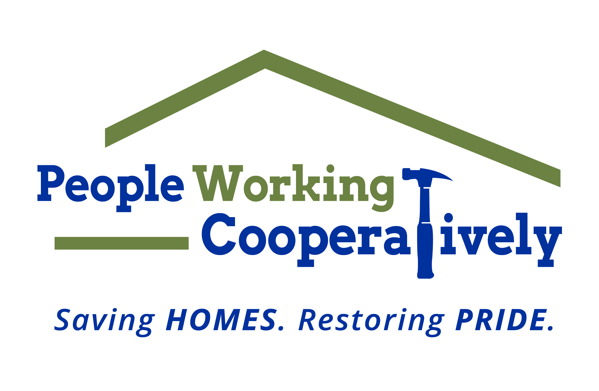
FOR IMMEDIATE RELEASE
Media Contact: Amber Potter, Scooter Media
(513) 236-8301 | amber@scootermediaco.com

People Working Cooperatively provides resources for protecting children from lead poisoning
Local organization raising awareness of long-term health effects during
National Lead Poisoning Prevention Week, Oct. 23-29

CINCINNATI (Oct. 10, 2022) – Approximately 3.6 million American households have children under the age of six living in homes with lead exposure hazards. Three out of four homes in Hamilton County alone may contain lead-based paint with more than 30,000 children living in these homes where they could be exposed.

The good news? Lead poisoning is preventable with the right resources.

National Lead Poisoning Prevention Week is Oct. 23-29 and raises awareness for the ways parents can reduce children’s exposure to lead in the home and prevent serious health effects. People Working Cooperatively (PWC) has partnered with the City of Cincinnati, the Hamilton County Department of Public Health and the Ohio Department of Health to serve as the centralized hub for information, programs and resources to connect families to the services they need.

“We know that the health impact of childhood lead poisoning can be devastating, leading to irreversible neurological damage,” said Nina Creech, Senior Vice President of Operations for Whole Home, a division of PWC. “We also know that nearly all lead poisoning happens in the home because lead has been used for a long time in a variety of products found in and around the house. By creating programs that address environmental health hazards where kids live, we can prevent those health problems from occurring.”

PWC President, Jock Pitts, agrees that safe housing plays an important role in our health, and it is the primary mission of the nonprofit.

“PWC’s mission is to keep families safe and healthy in their homes. Lead poisoning is a very real threat to that safety and health, but it is also very preventable,” said Jock Pitts, PWC President. “We have been working diligently on a county, city and state level to ensure that the lead poisoning prevention resources are easily accessible to everyone.”

How can you take the necessary steps to prevent lead poisoning in your home?
- If your home was built prior to 1978, consider hiring a licensed inspector to identify potential hazards.
- Check to see if you are eligible for assistance with removing lead paint, dust and soil hazards at your property. People Working Cooperatively’s lead hotline, (513) 366-4697, can help.
- If you’re planning a remodel, hire EPA-certified renovators who know how to work lead safe. Doing the work yourself? Check out the EPA’s website at epa.gov/lead to learn about working lead safe in your own home so you don’t create lead hazards.
- Get your water tested for lead. Greater Cincinnati Water Works customers can get their water tested for free and may be eligible for cost-sharing assistance to remove lead service lines. Learn more at la.mygcww.org.
- Keep your home clean. Follow the Ohio Department of Health’s tips on how to control lead dust at odh.ohio.gov.

Visit pwchomerepairs.org/leadprevention for more information and resources for how to stay safe in your home.

# # #

About People Working Cooperatively
Incorporated in 1975, People Working Cooperatively (PWC) is a non-profit organization serving low-income, elderly, and disabled homeowners in 21 counties of southwest Ohio, Dayton, northern Kentucky and southeast Indiana. PWC strengthens communities by providing professional, critical home repair, weatherization, and modification services to help residents stay safely in their homes. In the last 47 years, PWC’s staff of licensed, trained employees and dedicated corps of 3,000 volunteers have assisted more than 320,000 individuals. For more information, visit pwchomerepairs.org or call (513) 351-7921.

