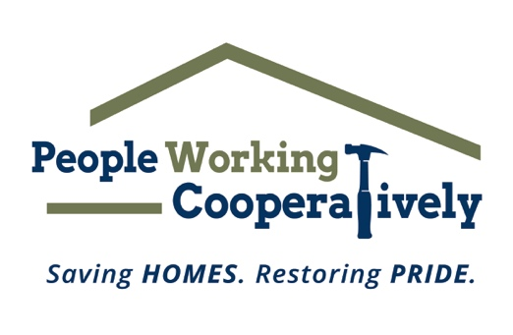
FOR IMMEDIATE RELEASE
Media Contact: Amber Potter, Scooter Media
(513) 236-8301 | amber@scootermediaco.com

Click here to access downloadable photos
Photos courtesy of People Working Cooperatively.

People Working Cooperatively and Samuel Adams Cincinnati Taproom team up for second annual cornhole tournament
The community is invited for the tapping of a new beer, cornhole and raffles to support services for low-income homeowners, August 6

CINCINNATI (July 12, 2023) – People Working Cooperatively’s (PWC) Emerging Leaders Board and the Samuel Adams Cincinnati Taproom are partnering for the second year in a row to host the Boards & Brews Cornhole Tournament from noon to 5 p.m. on Sunday, August 6.

The community is invited for an “ale” of a good time at the Taproom (1727 Logan St., Cincinnati) for beer, raffles and a cornhole tournament to raise awareness and support for PWC’s mission to perform critical home repairs and mobility modifications so that low-income homeowners can remain safe and living independently in their homes.

“Last year’s Boards & Brews Homebrew Competition and Cornhole Tournament provided a great opportunity to bring the mission of PWC to a whole new community – the homebrewing community. In light of last year’s success, we are excited to be back for the second year in a row,” said PWC president, Jock Pitts. “With the support of the Samuel Adams Cincinnati Taproom, we are able to garner more awareness and support for our mission to help neighbors in need stay safe and healthy in their homes.”

The event will kick off at noon with the announcement of the winning team of the Boards & Brews Homebrew Competition, in which local homebrewers submitted their best recipes for a chance to brew alongside Sam Adams Cincinnati Taproom Head Brewer, Chris Siegman. The winning beer will be officially tapped and available for purchase during the August 6 event.

The cornhole tournament starts at 12:30 p.m. during which teams of two players will compete for prizes. Tournament teams must register in advance, but recreational play will also be available the day of the event.

“This event is an excellent way to connect PWC with the homebrewing and beer communities in support of a good cause. It’s important to us to cultivate relationships with organizations in the community that are contributing to the common good,” said Siegman. “Plus, there is a special place in our hearts for homebrewers as our founder, Cincinnati’s own Jim Koch, got his start as a homebrewer. We are excited for another year of connecting with local homebrewers and reminding everyone what this event is all about helping neighbors in need.”

Registration for the cornhole tournament is open now through Saturday, August 5. The cost is $40 per team or $20 per individual. If guests do not have a partner, they are still encouraged to sign up as an individual and will be assigned a partner the morning of the event. All proceeds from the event benefit the programs and mission of PWC. To register for the cornhole tournament, visit pwchomerepairs.org/boards.

Not feeling competitive? This is a family-friendly event, and guests are welcome to stop by to try the winning homebrew recipe, enter a raffle, learn more about PWC or simply hang out with friends and neighbors.

Boards & Brews is possible thanks to the support and generosity of several sponsors, including Presenting Sponsor Samuel Adams Cincinnati Taproom.

# # #

About People Working Cooperatively
Incorporated in 1975, People Working Cooperatively (PWC) is a non-profit organization serving low-income, elderly, and disabled homeowners in 20 counties of southwest Ohio, Dayton, northern Kentucky and southeast Indiana. For 48 years, PWC has strengthened communities by providing professional, critical home repair, weatherization, and accessibility modification services to help residents stay safely in their homes. PWC’s staff of licensed, trained employees and dedicated corps of volunteers assist nearly 6,000 individuals in more than 3,500 homes each year. For more information, visit pwchomerepairs.org or call (513) 351-7921.

About The Samuel Adams Cincinnati Taproom
The Cincinnati Samuel Adams Taproom opened in November 2018 and is located near the historic Findlay Market and across the street from the Samuel Adams Brewery in Over-the-Rhine. It serves as a meeting place for beer drinkers, local Cincinnatians, and visitors alike where core, seasonal and even exclusive, experimental beers are available thanks to the proximity of the Brewery and the Taproom’s on-site research and development nano-brewery.

