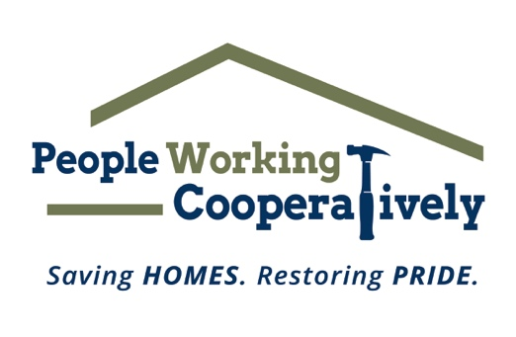
FOR IMMEDIATE RELEASE
Media Contact: Katie Forcade, Scooter Media
571-266-2878 | Katie@scootermediaco.com

Click here for Ryan McLane’s headshot.

People Working Cooperatively Welcomes New Board Member
Emerging Leaders Board Past President continues his support of the nonprofit’s mission with new role

CINCINNATI (Sept. 14, 2023) – People Working Cooperatively (PWC), the Greater Cincinnati/Northern Kentucky nonprofit dedicated to providing critical home repairs, energy conservation and accessibility modifications for low-income, elderly and homeowners with disabilities, is pleased to announce that former Emerging Leaders Board President, Ryan McLane, has joined the PWC Board of Directors.

McLane is a Wildcat, having received his B.A. in Political Science from the University of Kentucky in 2005 and later obtained his law degree from the UK College of Law in 2008. He is admitted to practice in Kentucky and Ohio, where he has represented hospitals, nursing homes, construction companies, and more. A partner in DBL Law’s Litigation & Dispute Resolution practice group, McLane focuses on business litigation, construction law, and medical malpractice defense. McLane served as a founder and past president of the Emerging Leaders Board – young professionals and emerging community leaders who support PWC’s mission by promoting awareness and encouraging involvement through community action.

“Ryan has shown that he has a passion and dedication for the work that we do in the community for our low-income neighbors in need through his participation as the inaugural president of the Emerging Leaders Board and his involvement with the PWC Development Committee,” said Jock Pitts, PWC President. “Ryan’s knowledge of PWC and our services and mission through his past work with the organization make him a great addition to the board, and we look forward to his continued support through this new role.”

PWC performs critical home repairs and modifications for low-income homeowners – many of whom are elderly, veterans, single parents or grandparents raising children, and individuals with disabilities – in communities throughout Greater Cincinnati to help them stay safe and healthy at home. The organization is often the only resource for these underserved community members and is committed to providing its professional expertise and services to help these local residents remain in their homes.

To learn more about People Working Cooperatively, if you qualify for services, or how you can support people in need in your community, visit www.pwchomerepairs.org or call (513) 351-7921.

# # #

About People Working Cooperatively
Incorporated in 1975, People Working Cooperatively (PWC) is a non-profit organization serving low-income, elderly, and disabled homeowners in 20 counties of southwest Ohio, Dayton, northern Kentucky and southeast Indiana. For 48 years, PWC has strengthened communities by providing professional, critical home repair, weatherization, and modification services to help residents stay safely in their homes. PWC’s staff of licensed, trained employees and dedicated corps of volunteers assist nearly 6,000 individuals in more than 3,500 homes each year. For more information, visit pwchomerepairs.org or call (513) 351-7921.

