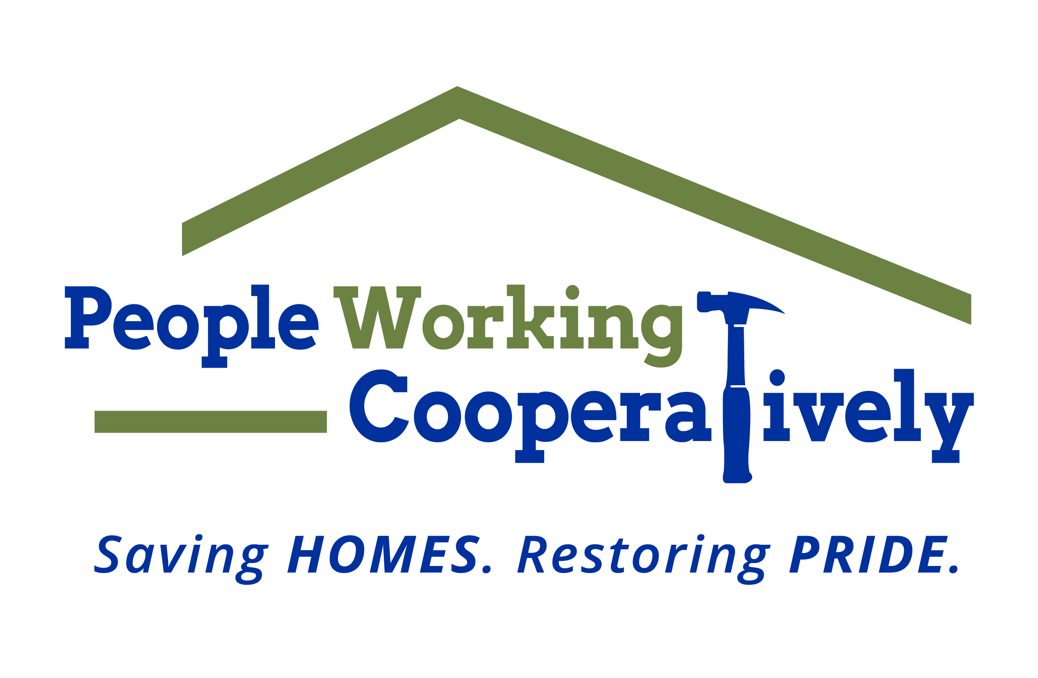
FOR IMMEDIATE RELEASE
Media Contact: Amber Potter, Scooter Media
513-236-8301 | amber@scootermediaco.com

People Working Cooperatively receives $2.5 million grant from Farmer Family Foundation
Single largest private donation in nonprofit’s history will help provide critical home repairs and modifications for low-income residents

CINCINNATI (May 25, 2023) – People Working Cooperatively (PWC) has received a $2.5 million grant from the Farmer Family Foundation – the nonprofit’s single largest private donation in its history. PWC’s staff of licensed, trained employees and dedicated corps of volunteers assist nearly 6,000 individuals in more than 3,500 homes each year. The grant will allow the nonprofit to implement a whole house service model across Hamilton, Clermont, Butler and Warren counties by providing the necessary critical home repairs, energy conservation services and mobility modifications needed for its low-income clients.

“The ability to address all of the home’s needs at one time is not only cost-effective and efficient, but it allows families to stay in their homes and gain economic stability from the improved conditions,” said PWC President Jock Pitts. “When a family can stay in their house, it relieves pressure on local systems to provide affordable housing and prevents homelessness. It can even improve health conditions such as asthma – a leading cause for child hospitalization. The work we can do because of these grant funds will be transformational – not only for PWC but for the families, neighbors and communities in which we serve.”

The Farmer Family Foundation is a nonprofit family foundation based in Cincinnati, Ohio, that aligns with organizations and programs that provide the potential to make a significant impact and transform peoples’ lives.

“PWC’s work in the community ensures that children in low-income households continue to live in safe spaces and remain in their schools with friends and peers. This stability leads to better academic performance and mental health,” said Brynne F. Coletti, Co-Chair, the Farmer Family Foundation. “A home is an asset that grows in value if it is maintained. This opportunity to pass equity and property on to the next generation provides a foundation for economic stability across generations, stabilizing local housing stock and neighborhoods.”

The grant will help PWC to decrease its waiting list of clients needing services while continuing to improve the health of its clients, stabilize neighborhoods through homeownership, preserve and build communities and keep underserved neighbors in need safe in their homes.

“We hope our grant will highlight the need for the important service PWC provides and inspires others to come along side us as we try to stabilize housing for individuals and families across our community,” said Joyce B. Farmer, Co-Founder, the Farmer Family Foundation.

To learn more about People Working Cooperatively and to see who qualifies for services, visit pwchomerepairs.org.

# # #

About People Working Cooperatively
Incorporated in 1975, People Working Cooperatively (PWC) is a non-profit organization serving low-income, elderly, and disabled homeowners in 20 counties of southwest Ohio, Dayton, northern Kentucky and southeast Indiana. For 48 years, PWC has strengthened communities by providing professional, critical home repair, weatherization, and modification services to help residents stay safely in their homes. PWC’s staff of licensed, trained employees and dedicated corps of volunteers assist nearly 6,000 individuals in more than 3,500 homes each year. For more information, visit pwchomerepairs.org or call (513) 351-7921.

About the Farmer Family Foundation
The Farmer Family Foundation is diligent in identifying programs with the potential to make a significant impact and transform peoples’ lives. The focus is on philanthropic investments that meet essential community needs and those that ensure Greater Cincinnati is thriving. The Foundation prioritizes investments in efforts that enhance K-12 education for at-risk individuals and enable economic self-sufficiency. Beyond the greater Cincinnati area, investments are selectively made to support health care research. Trustees – Joyce B. Farmer, Brynne F. and Bob Coletti, Scott and Mary Farmer, Amy F. and George Joseph.

