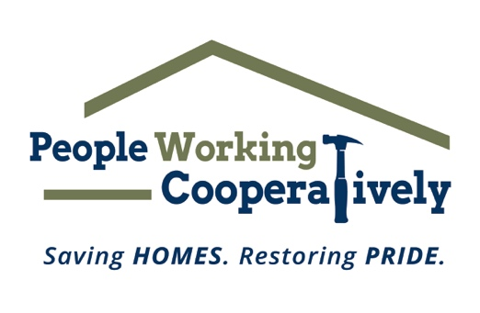
FOR IMMEDIATE RELEASE
Media Contact: Amber Potter, Scooter Media
(513) 236-8301 | amber@scootermediaco.com

Link to downloadable photos: https://drive.google.com/drive/folders/1XKC7mze_9mQDiqzMxCvxom33KnaIAn33?usp=sharing

People Working Cooperatively and Samuel Adams Cincinnati Taproom to Host Boards & Brews Event
Guests are invited to enjoy an afternoon of homebrewed beer and cornhole, August 7

CINCINNATI (July 18, 2022) – People Working Cooperatively’s (PWC) Emerging Leaders Board and the Samuel Adams Cincinnati Taproom are partnering for a “lager” than life event – the first annual Boards & Brews Homebrew Competition and Cornhole Tournament. On Sunday, August 7, from noon to 5 p.m., guests are invited to the Taproom (1727 Logan St., Cincinnati) for a day of food, beer, raffles and a cornhole tournament to raise funds to support PWC’s critical home repair and modification services for low-income residents.

The event will kick off at noon at the Taproom with the announcement of the winning team of the Boards & Brews Homebrew Competition, in which local homebrewers submitted their best recipes for a chance to brew it with head brewer, Chris Siegman. The winning beer will be officially tapped and available for purchase during the August 7 event.

Following the announcement of the winning homebrew team, guests are invited to enjoy a pint of the winning brew and participate in a cornhole tournament, where 32 teams of two players will compete for exciting prizes. Tournament teams must register in advance, but recreational play will also be available the day of the event.

“The PWC Emerging Leader’s Board has created a fun and compelling event that will provide a family-friendly afternoon of healthy competition,” said PWC president, Jock Pitts. “Through our partnership with Samuel Adams Cincinnati Taproom, we are creating exciting memories while also providing the opportunity for the community to learn more about and support the work PWC does throughout the year to help neighbors in need stay safe and healthy in their homes.”

Siegman agrees that the event is a great way to celebrate both the homebrewing and PWC communities and to share PWC’s impactful work throughout the region.

“Partnerships, like our relationship with PWC, are an important way for Sam Adams to connect meaningfully with our neighbors and share our values with drinkers,” said Siegman. “Our founder, Cincinnati’s own Jim Koch, got his start as a homebrewer. This collaboration with PWC really hits home for our Taproom team as we are able to connect with Cincinnati’s robust home brewing community while calling attention to PWC’s mission. It’s a win-win!”

Registration for the cornhole tournament is open now through August 6. The cost is $40 per team or $20 per individual. If guests do not have a partner, they are still encouraged to sign up as an individual and will be assigned a team member. All proceeds from the event benefit the programs and mission of PWC. To register for the cornhole tournament, visit pwchomerepairs.org/boards.

Boards & Brews is possible thanks to the support and generosity of several sponsors, including Presenting Sponsor Samuel Adams Cincinnati Taproom, Tournament Title Sponsor Omnia360 and Growler Sponsor DBL Law.

# # #

About People Working Cooperatively
Incorporated in 1975, People Working Cooperatively (PWC) is a non-profit organization serving low-income, elderly, and disabled homeowners in 21 counties of southwest Ohio, Dayton, northern Kentucky and southeast Indiana. PWC strengthens communities by providing professional, critical home repair, weatherization, and modification services to help residents stay safely in their homes. In the last 47 years, PWC’s staff of licensed, trained employees and dedicated corps of 3,000 volunteers have assisted more than 320,000 individuals. For more information, visit pwchomerepairs.org or call (513) 351-7921.

About The Samuel Adams Cincinnati Taproom
The Cincinnati Samuel Adams Taproom opened in November 2018 and is located near the historic Findlay Market and across the street from the Samuel Adams Brewery in Over-the-Rhine. It serves as a meeting place for beer drinkers, local Cincinnatians, and visitors alike where core, seasonal and even exclusive, experimental beers are available thanks to the proximity of the Brewery and the Taproom’s on-site research and development nano-brewery

