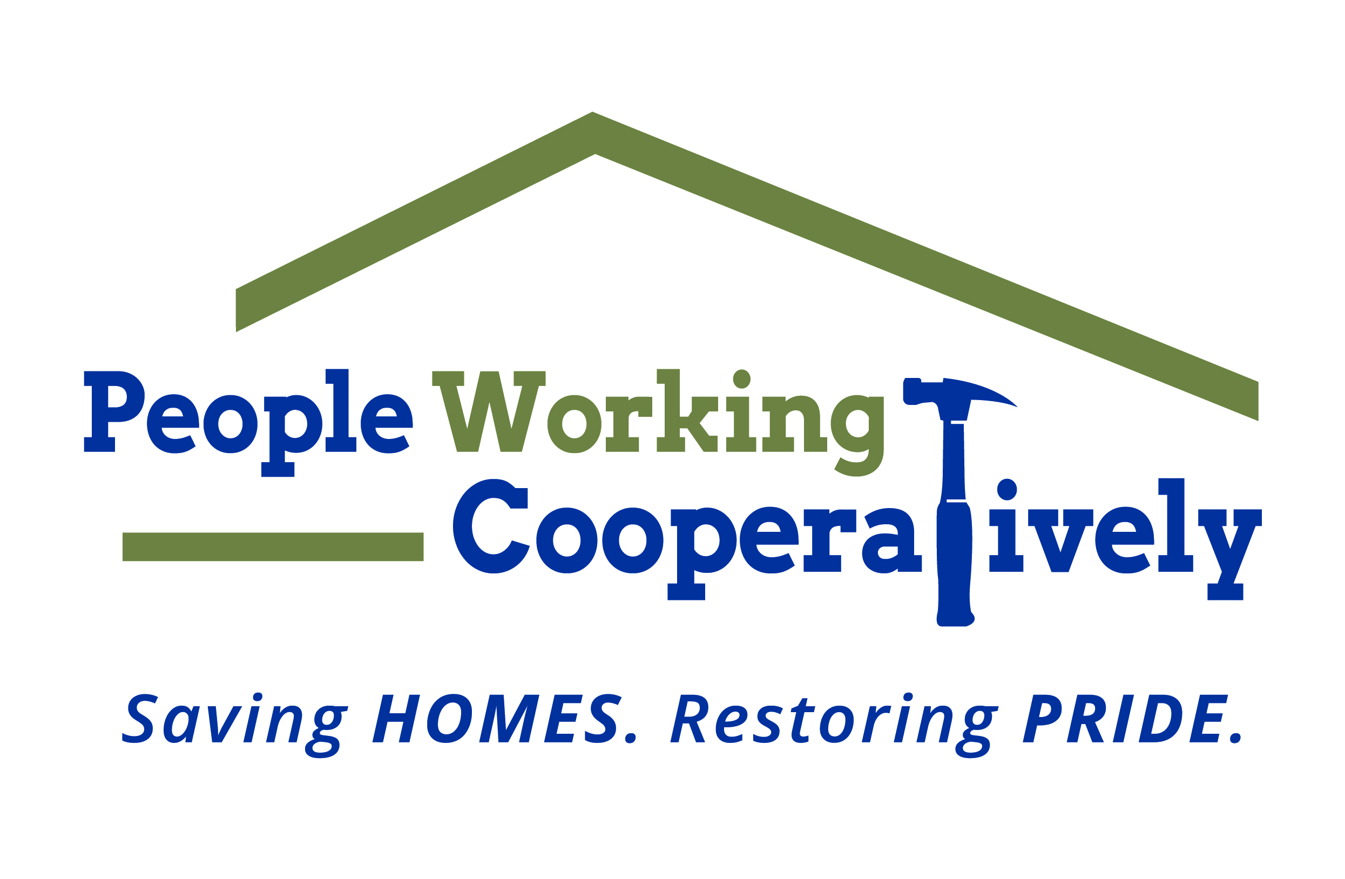
FOR IMMEDIATE RELEASE
Media Contact: Amber Potter, Scooter Media
513-236-8301 | amber@scootermediaco.com

PWC receives $50,000 grant from Charles H. Dater Foundation
Grant funding to support Student Service Program

CINCINNATI (July 20, 2023) – People Working Cooperatively (PWC), the Greater Cincinnati area nonprofit that provides critical home repairs, accessibility modifications and energy conservation services from professional trades staff at no cost for low-income homeowners, has received a $50,000 grant from the Charles H. Dater Foundation.

The grant will help to fund PWC’s Student Service Program, a component of the Volunteer Involvement Program, which engages youth in important and meaningful volunteer experiences that benefit both the students and low-income residents of Greater Cincinnati.

“PWC’s Student Service Program provides impactful service opportunities for young volunteers, which helps us to reach more people in need of critical home repair and yard maintenance services across the region,” said Jock Pitts, PWC President. “This experience also offers the students valuable technical and interpersonal skills they can use in future endeavors and cultivates a commitment to service.”

By leveraging the time and skills of other PWC volunteers with the Student Service Program, PWC is able to maximize the benefit to the homeowner and provide more engaging and meaningful service learning opportunities for student volunteers.

During the 2023 program, PWC anticipates that approximately 300 youth volunteers will participate in the summer student services program. These students together with young participants in group projects and PWC’s two major volunteer events, Prepare Affair and Repair Affair, will provide more than 3,800 hours of service providing important services for low-income households across Greater Cincinnati ensuring homeowners can stay safe, independent, and healthy in their own homes.

To learn more about People Working Cooperatively and who is eligible for services, visit pwchomerepairs.org or call (513) 351-7921.

# # #

About People Working Cooperatively
Incorporated in 1975, People Working Cooperatively (PWC) is a non-profit organization serving low-income, elderly, and disabled homeowners in 20 counties of southwest Ohio, Dayton, northern Kentucky and southeast Indiana. For 48 years, PWC has strengthened communities by providing professional, critical home repair, weatherization, and modification services to help residents stay safely in their homes. PWC’s staff of licensed, trained employees and dedicated corps of volunteers assist nearly 6,000 individuals in more than 3,500 homes each year. For more information, visit pwchomerepairs.org or call (513) 351-7921.

