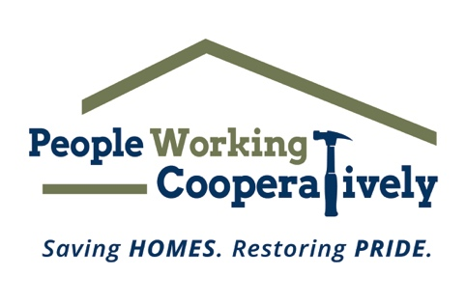
FOR IMMEDIATE RELEASE
Media Contact: Katie Forcade, Scooter Media
571-266-2878 | Katie@scootermediaco.com

Link: Downloadable photos and b-roll
Photo/video credit: People Working Cooperatively

People Working Cooperatively Seeks Prepare Affair Volunteers
Help neighbors in need by raking leaves, cleaning gutters to prepare homes for winter

CINCINNATI, Ohio (Oct. 25, 2023) – Are you looking for a way to positively impact the community and improve the quality of life for friends and neighbors in need? All it takes is a rake and some gloves to make a difference during People Working Cooperatively’s (PWC) annual fall volunteer event known as Prepare Affair.

Throughout the month of November, more than 2,000 volunteers will provide fall cleanup services for hundreds of low-income seniors, veterans and people with disabilities throughout Cincinnati and Northern Kentucky to help prepare homes and lawns for cold weather. All ages and skill levels are welcome to participate, and signing up is as simple as registering online. Volunteers can join forces with friends, co-workers, church groups and family members to create their own crew; or individuals can join an existing team.

“At PWC, our mission is to keep people safe and healthy in their homes. Prepare Affair is one of the largest volunteer events in the region during which community members help their neighbors with minor winter preparation tasks that they physically can’t tackle themselves,” said PWC President Jock Pitts. “Our waiting list for services are long and it’s volunteer events like this that make it possible to help as many people prepare for the upcoming winter season as possible. Not only will volunteers be helping often-underserved individuals, but it’s a chance to get to know new people, team build with co-workers or charity organizations and see the difference you’re making in the community first-hand.”

Prepare Affair projects range from raking leaves and cleaning gutters to other minor winter preparation tasks that help residents keep their homes safe and livable throughout the cold-weather season. PWC will be celebrating Prepare Affair on Saturday, Nov. 18, but volunteers are invited to schedule their service on any day in November that works best for them.

Registration is available online at pwchomerepairs.org/prepare-affair. For more information, contact Brian McLaughlin, PWC Volunteer Program Manager, at 513-351-7921.

Prepare Affair is presented by The City of Cincinnati.

# # #

About People Working Cooperatively
Incorporated in 1975, People Working Cooperatively (PWC) is a non-profit organization serving low-income, elderly, and disabled homeowners in 20 counties of southwest Ohio, Dayton, northern Kentucky, and southeast Indiana. For more than 48 years, PWC has strengthened communities by providing professional, critical home repair, weatherization, and modification services to help residents stay safely in their homes. PWC’s staff of licensed, trained employees and dedicated corps of volunteers assist nearly 6,000 individuals in more than 3,500 homes each year. For more information, visit pwchomerepairs.org or call (513) 351-7921.

