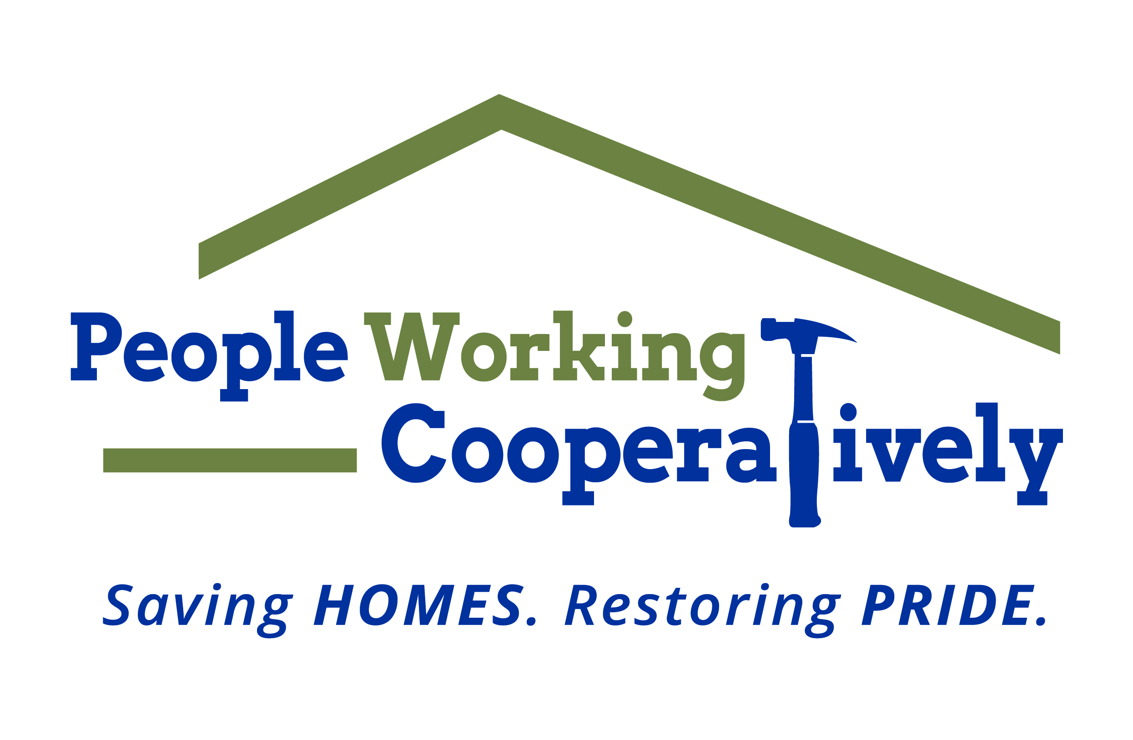
FOR IMMEDIATE RELEASE
Media Contact: Amber Potter, Scooter Media
513-236-8301 | amber@scootermediaco.com

People Working Cooperatively receives grant from Installed Building Products Foundation
Local nonprofit receives funds to support mission of providing critical home repair and modification services to low-income residents

CINCINNATI (Feb. 23, 2023) – People Working Cooperatively (PWC) announced it has received a $50,000 grant from the Installed Building Products Foundation, a Columbus, Ohio-based foundation that provides major grants for organizations involved in building or renovating homes or providing shelter for those in need.

PWC is a nonprofit that provides professional, critical home repair, weatherization, and accessibility modification services for low-income homeowners in communities throughout Greater Cincinnati to help them stay safe and healthy at home.

“We’re grateful to have a partner like the Installed Building Products Foundation support our work to ensure that our neighbors in need have a safe and healthy place to call home,” said Chris Owens, Vice President of Development for PWC. “These funds will allow us to improve the communities we serve by improving the safety and accessibility of the homes in those communities.”

The Installed Building Products Foundation is funded by Installed Building Products, one of the nation's largest new residential insulation installers. Funded in part by IBP employees, the Foundation aims to serve its employees – more than 10,000 across more than 200 locations across the U.S. – and the communities they live in. Through the Foundation’s Building Homes program, the Foundation awards funds to eligible nonprofits whose mission is to provide safe housing for those in need.

“Having a safe, comfortable place to call home at the end of the day is at the heart of
what IBP does,” said IBP Foundation President Kelly Clifford Riehl. “Forming a partnership with PWC allows us to support an incredible organization that is doing amazing work for their community.”

# # #

About People Working Cooperatively
Incorporated in 1975, People Working Cooperatively (PWC) is a nonprofit organization serving low-income, elderly, and disabled homeowners in 20 counties of southwest Ohio, Dayton, northern Kentucky and southeast Indiana. For 48 years, PWC has strengthened communities by providing professional, critical home repair, weatherization, and modification services to help residents stay safely in their homes. PWC’s staff of licensed, trained employees and dedicated corps of volunteers assist nearly 6,000 individuals in more than 3,500 homes each year. For more information, visit pwchomerepairs.org or call (513) 351-7921.

About the Installed Building Products Foundation
Installed Building Products, Inc. is one of the nation's largest new residential insulation
installers and is a diversified installer of complementary building products. The Installed
Building Products Foundation was started by and for IBP employees and their
communities in 2019. For more information, visit
installedbuildingproducts.com/sustainability.

