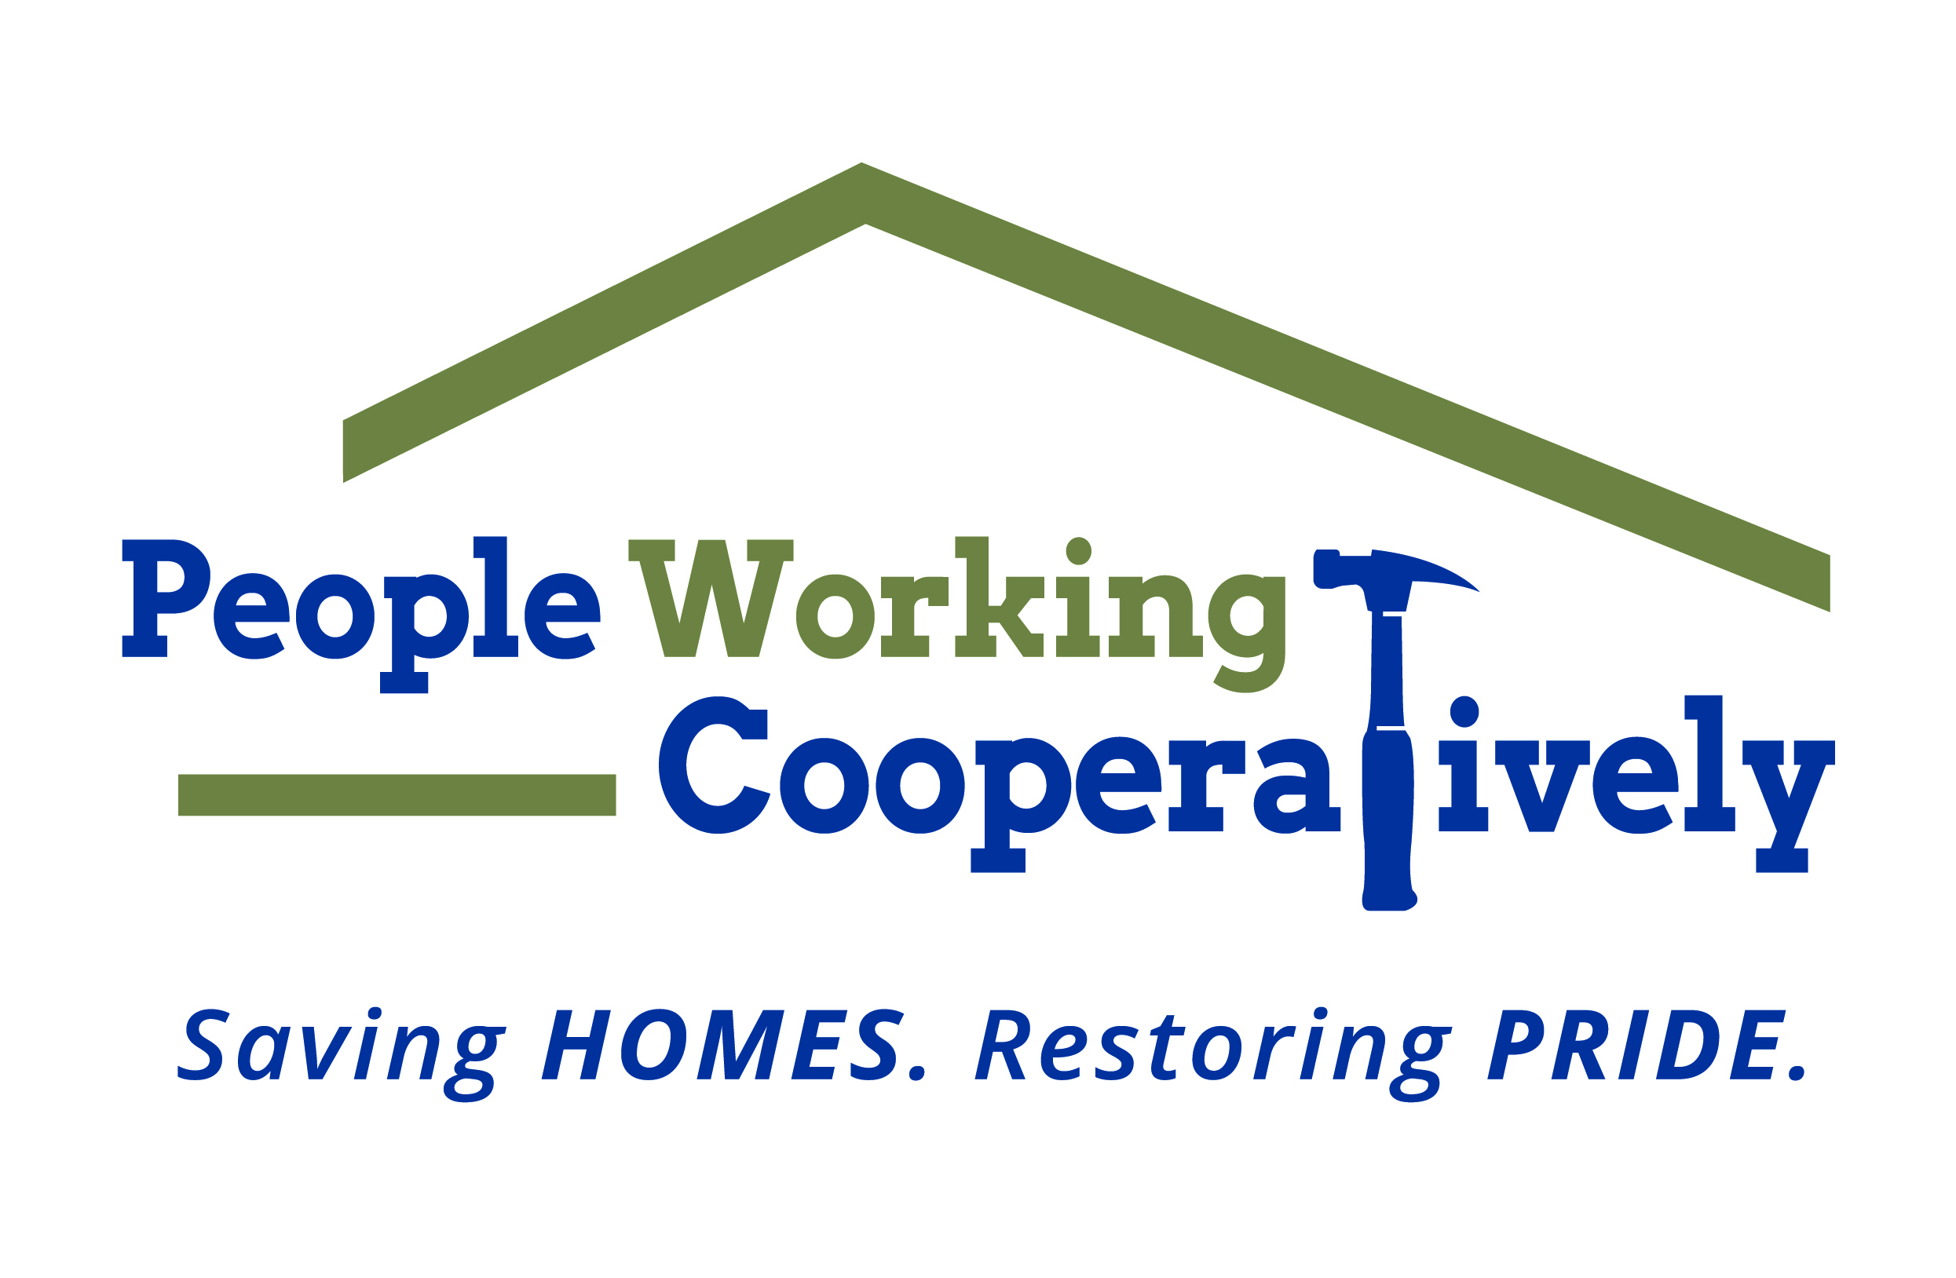
FOR IMMEDIATE RELEASE
Media Contact: Katie Forcade, Scooter Media
(571)-266-2878 | katie@scootermediaco.com

People Working Cooperatively provides resources for protecting children from lead poisoning
Local organization raising awareness of long-term health effects during
National Lead Poisoning Prevention Week and beyond

CINCINNATI (Oct. 23, 2023) – Approximately 3.3 million American households have children under the age of six living in homes with lead exposure hazards. In Hamilton County alone, three out of four homes were built before lead paint was banned for residential use in 1978, and nearly 40,000 homes pose a significant risk of lead exposure.

The good news? Lead poisoning is preventable with the right resources.

National Lead Poisoning Prevention Week is Oct. 22-28 and raises awareness for the ways parents can reduce children’s exposure to lead in the home and prevent serious health effects. People Working Cooperatively (PWC) has partnered with the City of Cincinnati and the Hamilton County Department of Public Health to serve as the centralized hub for information, programs and resources to connect families to the services they need.

“Many people in the community don’t realize that lead paint is still an issue today, especially in a city with many historic homes built prior to 1978 when lead paint was banned by the federal government for consumer use,” said Nina Creech, Senior Vide President for PWC. “The vast majority of lead poisoning happens inside the home, and it’s particularly hazardous to children under the age of six causing irreversible damage. By providing resources and creating programs to address the environmental health hazards where our kids are living, we can prevent the damage to their health.”

PWC President, Jock Pitts, agrees that safe housing plays an important role in our health, and it is the primary mission of the nonprofit.

“Our mission is to keep families safe and healthy in their homes. Lead poisoning is a very real threat to that safety and health, but it is also very preventable,” Pitts said. “People Working Cooperatively is here to help people understand what is lead poisoning, why is it harmful and what resources exist locally to help them address the issue.”

How can you take the necessary steps to prevent lead poisoning in your home?
- If your home was built prior to 1978, check to see if you are eligible for assistance with removing lead paint, dust and soil hazards at your property. People Working Cooperatively’s lead hotline, (513) 366-4697, can help.
- Consider hiring a licensed inspector to identify potential hazards.
- If you’re planning a remodel, hire EPA-certified renovators who know how to work lead safe. Doing the work yourself? Check out the EPA’s website at epa.gov/lead to learn about working lead safe in your own home so you don’t create lead hazards.
- Get your water tested for lead. Greater Cincinnati Water Works customers can get their water tested for free and may be eligible for cost-sharing assistance to remove lead service lines. Learn more at la.mygcww.org
- Keep your home clean. Follow the Ohio Department of Health’s tips on how to control lead dust at odh.ohio.gov.

Visit pwchomerepairs.org/leadprevention for more information and resources for how to stay safe in your home.

# # #

About People Working Cooperatively
Incorporated in 1975, People Working Cooperatively (PWC) is a non-profit organization serving low-income, elderly, and disabled homeowners in 20 counties of southwest Ohio, Dayton, northern Kentucky, and southeast Indiana. For more than 48 years, PWC has strengthened communities by providing professional, critical home repair, weatherization, and modification services to help residents stay safely in their homes. PWC’s staff of licensed, trained employees and dedicated corps of volunteers assist nearly 6,000 individuals in more than 3,500 homes each year. For more information, visit pwchomerepairs.org or call (513) 351-7921.

