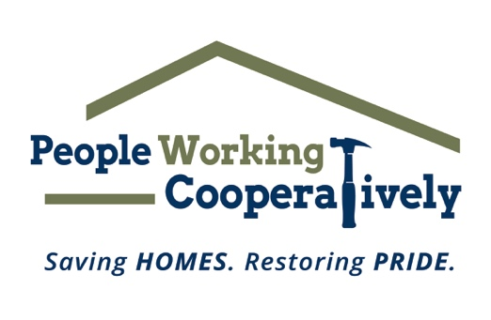

FOR IMMEDIATE RELEASE
Media Contact: Katie Forcade, Scooter Media
571-266-2878 | katie@scootermediaco.com

People Working Cooperatively honors volunteers at
Annual Recognition Celebration, October 18

CINCINNATI (Sept. 25, 2023) – People Working Cooperatively (PWC) is hosting its Annual Recognition Celebration at The Grand Ballroom in Covington, Kentucky, on Wednesday, Oct. 18, to honor individuals in the community that have made a significant impact on its mission to save homes and restore pride.

PWC provides professional, critical home repair, weatherization and accessibility modification services for low-income homeowners throughout Greater Cincinnati. Many of PWC’s clients are elderly, veterans, single parents or grandparents raising children, and individuals with disabilities living on a fixed income. With the need for services outweighing resources, PWC relies on the support of its dedicated corps of volunteers, in addition to its staff of licensed and trained employees, to help residents remain living independently.

“Because of the work we do every day, our neighbors in need stay healthy and safe in their own homes,” said Jock Pitts, PWC President. “Our Annual Recognition Celebration honors those in the community who give their time and skills to help us achieve and further our mission—including volunteers, local businesses, our staff, and like-minded organizations. We are so grateful for their support and dedication.”

The 2023 award recipients are:
- Chairman’s Award: Allied Construction Industries
- Friend of PWC Awards: The Carol Ann & Ralph V. Haile, Jr. Foundation, Prus Construction Co., Huber Lumber
- Volunteer of the Year Awards: Mike Beeby, John King
- PWC Employees of the Year Awards: Ron Henlein, Brad Pierce
- Dan Ober Volunteer Hall of Fame Inductees: Larry Barber, Charlie Patty, Tanya Simpson

Registration opens at 11:30 a.m. and lunch and the program begin at noon. Individual reservations are $45, and a table sponsorship is $500. Tickets are available for purchase through Oct. 12 at pwchomerepairs.org/annualrecognition.

For more information about the Annual Recognition Celebration and People Working Cooperatively, visit pwchomerepairs.org or call (513) 351-7921.

# # #

About People Working Cooperatively
Incorporated in 1975, People Working Cooperatively (PWC) is a non-profit organization serving low-income, elderly, and disabled homeowners in 20 counties of southwest Ohio, Dayton, northern Kentucky, and southeast Indiana. For more than 48 years, PWC has strengthened communities by providing professional, critical home repair, weatherization, and modification services to help residents stay safely in their homes. PWC’s staff of licensed, trained employees and dedicated corps of volunteers assist nearly 6,000 individuals in more than 3,500 homes each year. For more information, visit pwchomerepairs.org or call (513) 351-7921.

