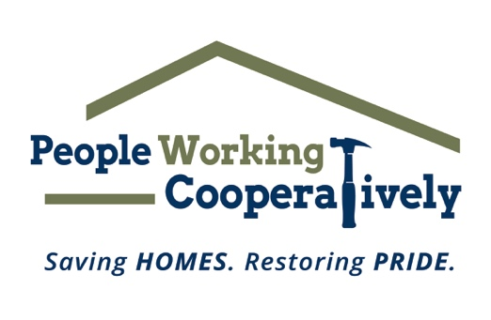

FOR IMMEDIATE RELEASE
Media Contact: Katie Forcade, Scooter Media
571-266-2878 | Katie@scootermediaco.com

People Working Cooperatively Receives Matching Grant from The Farmer Family Foundation
Local nonprofit needs community's help to maximize funds for home repairs and modifications for low-income neighbors

CINCINNATI (March 15, 2024) – People Working Cooperatively (PWC) has received a matching grant of $1,000,000 from The Farmer Family Foundation, funds which will help to address a waiting list of clients in need of home repairs and modifications in Butler, Clermont, Hamilton, and Warren counties.

People Working Cooperatively serves low-income, elderly, and disabled homeowners across southwest Ohio, Dayton, Northern Kentucky, and southeast Indiana with professional critical home repair, weatherization, and accessibility modification services so residents can stay safely in their homes.

The foundation generously awarded PWC last year with the organization’s largest single private donation in its history. To continue to support the good work being done in the community, the foundation will match up to $1,000,000 in new donations received between March 15 and November 15, 2024. Donations can be made by visiting https://support.pwchomerepairs.org/doubleyourgift.

“Through these funds, we will be able to continue whittling down our waiting list of clients needing critical repairs and mobility modifications in four counties,” said PWC President Jock Pitts. “We encourage everyone in the community to get involved and make a gift to PWC because these matching grant funds enable us all to make a positive impact for our neighbors in need. When a family can safely stay in their house, it relieves pressure on local systems to provide affordable housing, prevents homelessness and stabilizes neighborhoods.”

The grant is given on behalf of The Farmer Family Foundation and its Trustees—Joyce Farmer, Brynne and Bob Coletti, Scott and Mary Farmer, and Amy and George Joseph.

“The Farmer Family Foundation is proud to partner with PWC again to promote housing stability for families in Hamilton, Clermont, Butler and Warren counties,” said Scott Farmer, trustee with the Farmer Family Foundation. “We hope our $1 for $1 match will inspire others to support PWC and the invaluable services it provides for families to achieve economic self-sufficiency.”

The Farmer Family Foundation is a nonprofit family foundation based in Cincinnati, Ohio, that aligns with organizations and programs that provide the potential to make a significant impact and transform people’s lives.

To learn more about People Working Cooperatively, to donate, and to see who qualifies for services, visit PWChomerepairs.org.

# # #
About People Working Cooperatively
Incorporated in 1975, People Working Cooperatively (PWC) is a non-profit organization serving low-income, elderly, and disabled homeowners in 20 counties of southwest Ohio, Dayton, northern Kentucky and southeast Indiana. For 49 years, PWC has strengthened communities by providing professional, critical home repair, weatherization, and modification services to help residents stay safely in their homes. PWC’s staff of licensed, trained employees and dedicated corps of volunteers assist nearly 6,000 individuals in more than 3,500 homes each year. For more information, visit pwchomerepairs.org or call (513) 351-7921.

About the Farmer Family Foundation
The Farmer Family Foundation is diligent in identifying programs with the potential to make a significant impact and transform people’s lives. The focus is on philanthropic investments that meet essential community needs and those that ensure Greater Cincinnati is thriving. The Foundation prioritizes investments in efforts that enhance K-12 education for at-risk individuals and enable economic self-sufficiency. Beyond the greater Cincinnati area, investments are selectively made to support health care research. Trustees – Joyce B. Farmer, Brynne F. and Bob Coletti, Scott and Mary Farmer, Amy F. and George Joseph.

