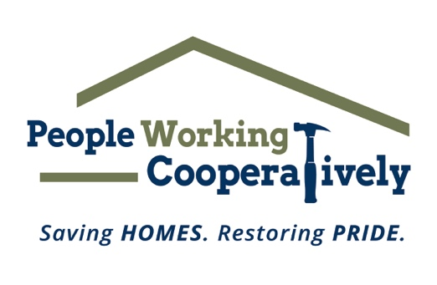

FOR IMMEDIATE RELEASE
Media Contact: Katie Forcade, Scooter Media
571-266-2878 | Katie@scootermediaco.com

Farmer Family Foundation matches more than $633,000 raised by People Working Cooperatively
Funds will help local nonprofit address critical home repairs, accessibility modifications for neighbors in need

CINCINNATI (Jan. 23, 2025) – Local nonprofit People Working Cooperatively (PWC) announced that its fundraising efforts from March 15 to Nov. 15, 2024, raised a total of $633,619.55 toward a matching grant provided by The Farmer Family Foundation and its Trustees. Every dollar has been doubled thanks to the Foundation’s generosity for a total of $1,267,240 to provide home repairs and modifications for our neighbors in need.

These funds will be used to reduce PWC’s waitlist of homeowners in Butler, Clermont, Hamilton, and Warren counties who urgently need home repairs or accessibility modifications. Projects include fixing broken water pipes, heating issues, electrical hazards, ramp installation, and more by PWC’s trained, licensed, and bonded staff of skilled tradespeople.

“We are deeply grateful to everyone who supported PWC during this fundraising period,” said Jock Pitts, PWC President. “We also want to extend a heartfelt thank you to The Farmer Family Foundation for matching the generosity of our community. These contributions will enable us to assist many, many families who would otherwise struggle to manage these necessary home repairs on their own, ensuring they can remain safe and healthy in their homes.”

Of note, PWC’s annual Ramp It Up for Veterans telethon, which aired on WCPO Channel 9 on Veterans Day (November 11), raised $44,437, which was counted toward the matching grant. These funds will directly support home repairs and accessibility improvements for local veterans.

As PWC celebrates 50 years of service in 2025, the organization invites community members to start the new year by supporting neighbors in need. Opportunities include volunteering, attending annual events, or making a monetary gift. To learn more about ways to get involved this new year, visit pwchomerepairs.org.

# # #

About People Working Cooperatively
Incorporated in 1975, People Working Cooperatively (PWC) is a non-profit organization serving low-income, elderly, and disabled homeowners in 20 counties of southwest Ohio, Dayton, northern Kentucky and southeast Indiana. For 50 years, PWC has strengthened communities by providing professional, critical home repair, weatherization, and modification services to help residents stay safely in their homes. PWC’s staff of licensed, trained employees and dedicated corps of volunteers assist nearly 6,000 individuals in more than 3,500 homes each year. For more information, visit pwchomerepairs.org or call (513) 351-7921.

About the Farmer Family Foundation
The Farmer Family Foundation is diligent in identifying programs with the potential to make a significant impact and transform people’s lives. The focus is on philanthropic investments that meet essential community needs and those that ensure Greater Cincinnati is thriving. The Foundation prioritizes investments in efforts that enhance K-12 education for at-risk individuals and enable economic self-sufficiency. Beyond the greater Cincinnati area, investments are selectively made to support health care research. Trustees – Joyce B. Farmer, Brynne F. and Bob Coletti, Scott and Mary Farmer, Amy F. and George Joseph.

