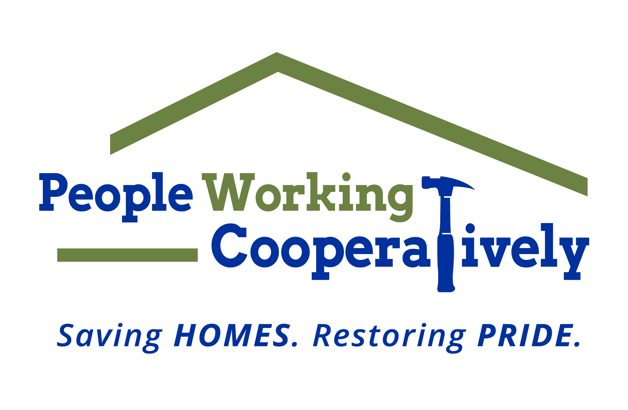
Media Contact: Jamie Glavic, Scooter Media
(859) 409-9943 | jamie@scootermediaco.com

FOR IMMEDIATE RELEASE

People Working Cooperatively Receives $120,000 from The Home Depot Foundation for Veteran Home Repairs and Modifications in Greater Cincinnati

CINCINNATI – People Working Cooperatively (PWC) has received a $120,000 grant from The Home Depot Foundation, which will be used to assist local veterans in need of critical home repairs and accessibility modifications to stay safely in their homes.

“We are thankful for The Home Depot Foundation’s continued support and dedication to the veteran community,” said Chris Owens, Vice President of Development at People Working Cooperatively. “With nearly 9,000 veterans over the age of 65 living in poverty in the Tri-State, these funds will make a substantial impact in the lives of veterans and their families across the region.”

Currently, there are over 175 veterans who proudly served our country on a waiting list for PWC’s services. In the last five years, PWC has provided services for over 3,200 households of veterans or their surviving spouses.

To learn more about People Working Cooperatively, or to find out if you qualify for services, visit pwchomerepairs.org or call (513) 351-7921.

###

About People Working Cooperatively
Incorporated in 1975, People Working Cooperatively (PWC) is a non-profit organization serving low-income, elderly, and disabled homeowners in 19 counties of Greater Cincinnati, Dayton, Northern Kentucky and Indiana. PWC strengthens communities by providing professional, critical home repair, weatherization, and modification services to help residents stay safely in their homes. In the last 45 years, PWC’s staff of licensed, trained employees and dedicated corps of 3,000 volunteers have assisted more than 320,000 individuals. For more information, visit pwchomerepairs.org or call (513) 351-7921.

