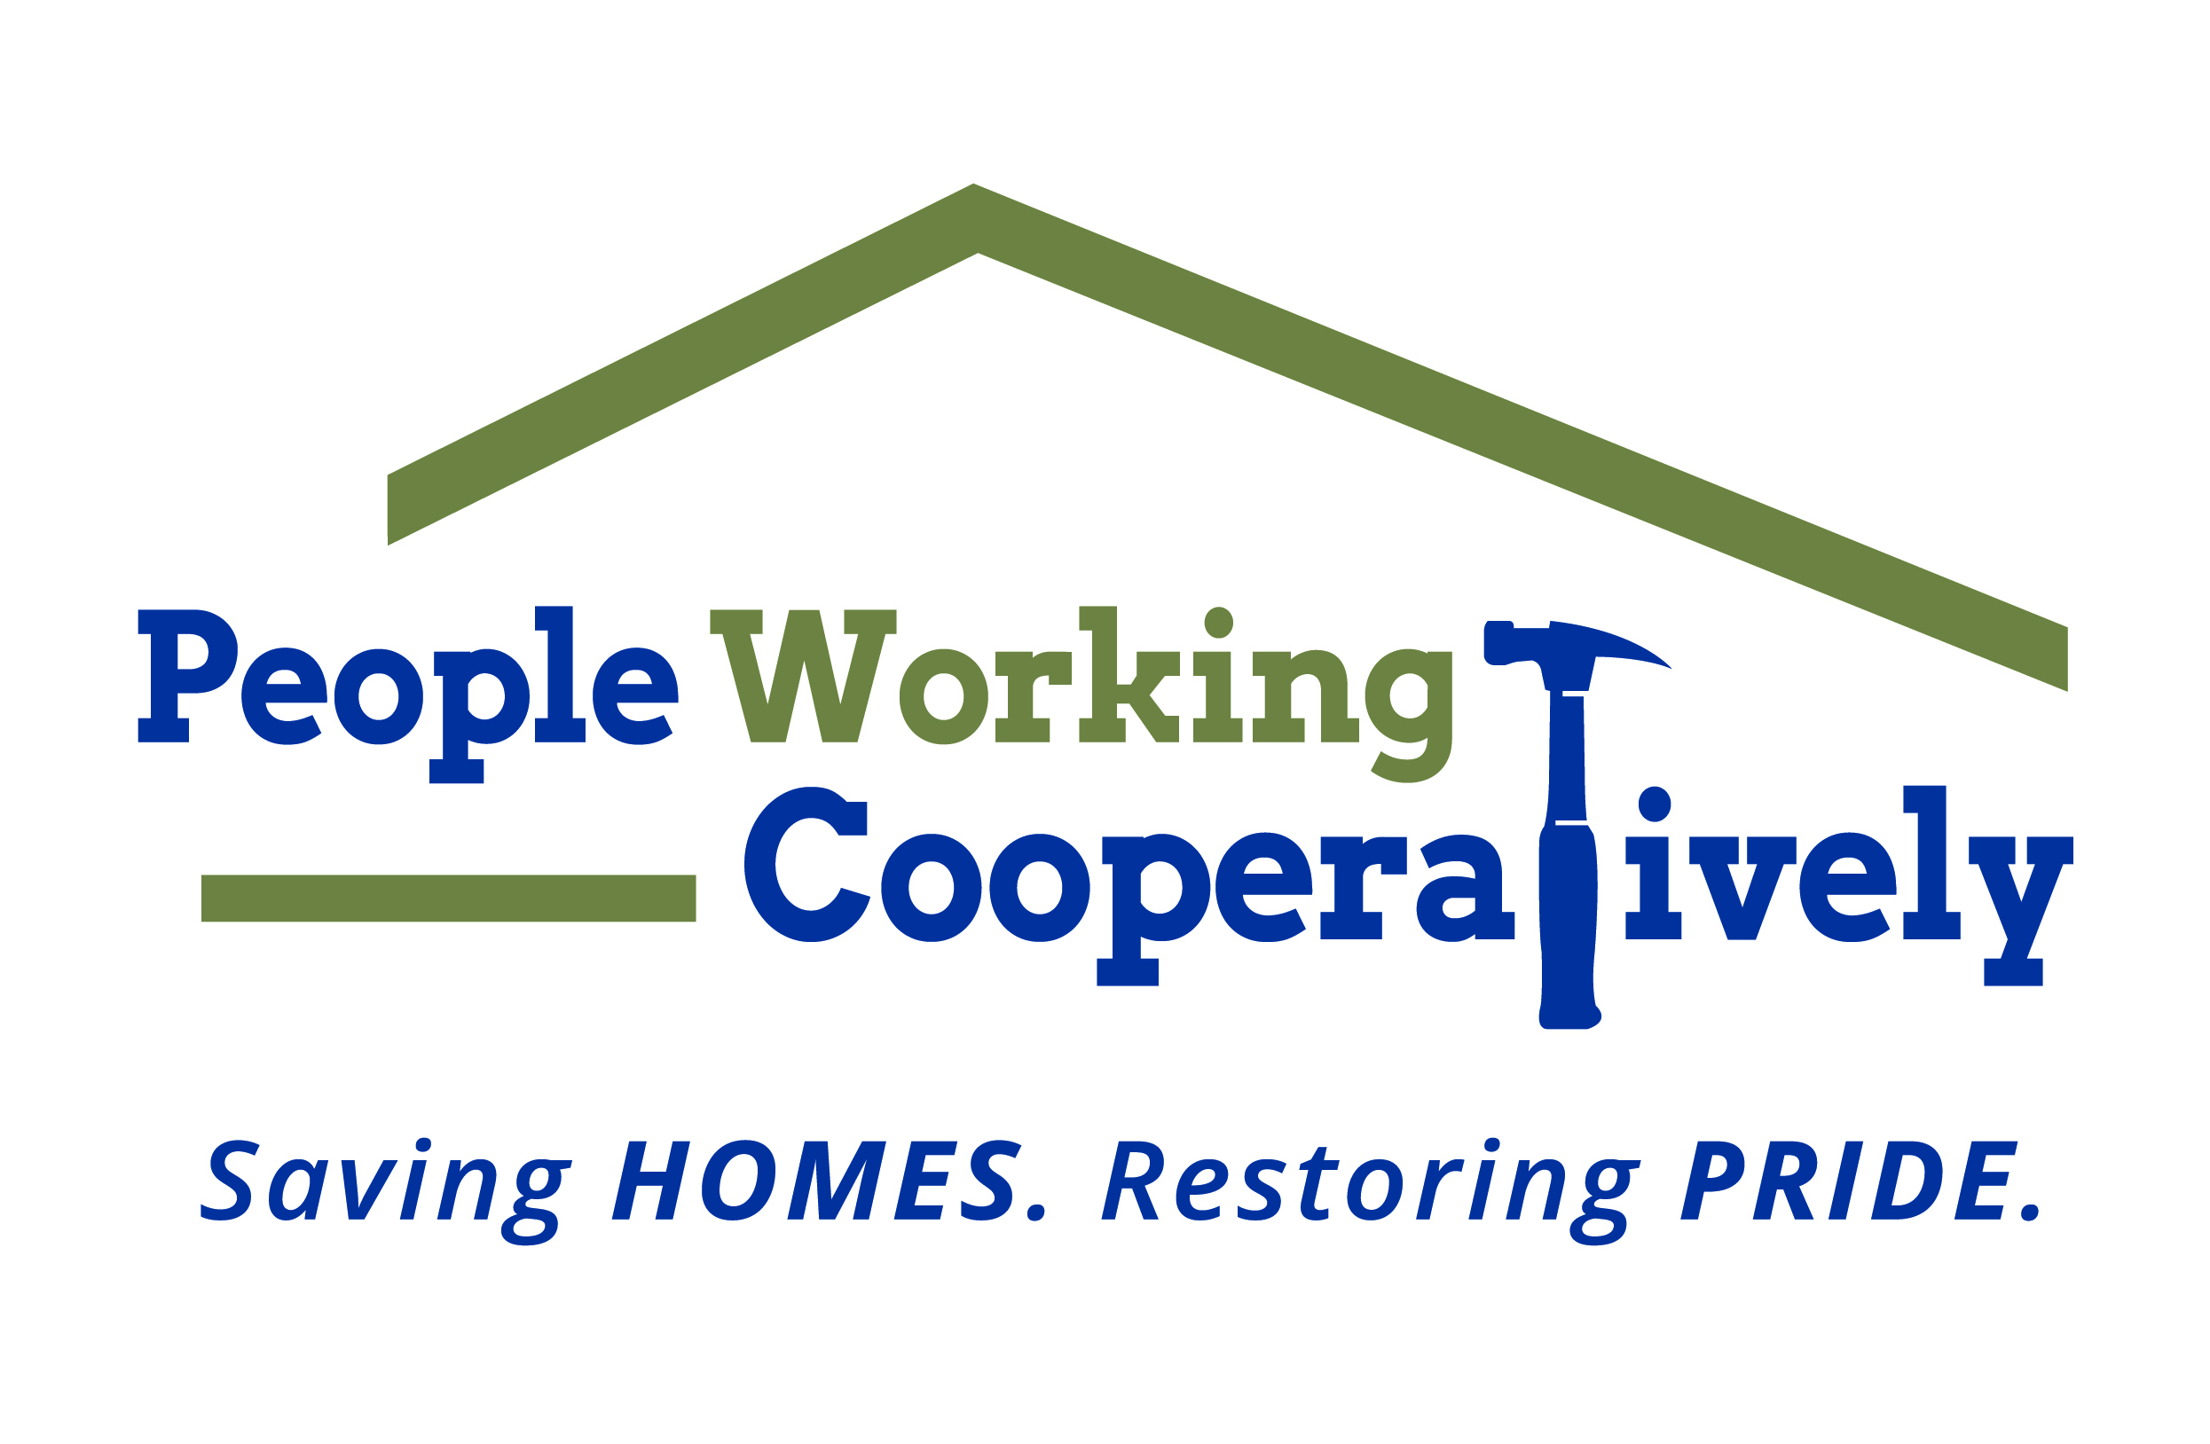
Media Contact: Jamie Glavic, Scooter Media
(859) 409-9943 | jamie@scootermediaco.com

FOR IMMEDIATE RELEASE

COVID-19 Funding Broadens People Working Cooperatively’s
Service Base Throughout Tri-State
$175,000 in Grants Support Health and Safety Emergency Repairs Across Region

Cincinnati, OH (May 5, 2020) – People Working Cooperatively (PWC) has been awarded $175,000 in grant funds to provide health and safety emergency repairs for those most impacted by COVID-19 (novel coronavirus). The funds will allow families with young children, seniors, people with disabilities and other individuals to stay healthy at home as the region continues to shelter-in-place.

Community Care in Action: PWC is Here to Help

“The economic and social impact of the coronavirus cannot be overstated,” said Jock Pitts, PWC President and CEO. “These funds allow us to not only address the emergency repairs of our current client base, which continues to grow, but to expand our reach and secure a much needed lifeline for those who find themselves in new, uncertain circumstances - and may not be familiar with our services.”

For the last 45 years, PWC has been committed to serving the region’s low-income, elderly and disabled homeowners across 20 counties of Greater Cincinnati, Dayton, Northern Kentucky and Indiana. In the wake of the COVID-19 pandemic, PWC has begun more than 260 urgent health and safety projects. To date, PWC has 340 emergency requests in queue. PWC has helped people like:

- Linda, a Colerain resident, was able to have two stair lifts installed in the home she shares with her husband, an amputee in need of dialysis treatments. The couple needed the lifts after both fell following Linda’s attempt to assist him down the stairs;
- Patricia, a Westwood resident, had been facing security issues from a broken door. Each night she wedged knives in between the door and doorframe with a chair propped behind it, hoping to keep out any potential intruders. She was scared and too anxious to sleep at night. PWC provided and installed a secure door, making Patricia feel safe in her own home again.
The recent receipt of COVID-19 Regional Response Funds allows PWC to expand their emergency services client base to serve Tri-State residents with an immediate need; those who may be unemployed, underemployed or experiencing recent financial hardship and/or health complications related to COVID-19.

“People across the Tri-State are scared and anxious about the potential or new health and financial hardships they are facing,” said PWC Vice President of Development Chris Owens. “Imagine being told to shelter-in-place but you don’t have water, heat, or you were laid off with little to no funds to address the issues in your home. That’s where PWC comes in; this funding will make an immediate impact for so many who are experiencing personal and professional turmoil as a result of this pandemic.”

PWC’s health and safety emergency repairs are an essential service. Health and safety emergency repairs are defined as issues that pose an immediate threat to the homeowner’s well-being, including:

- No working heat or water
- Gas fumes present
- An electrical condition posing a fire threat
- Accessibility modification to allow a client to return home
- First-floor doors or windows cannot be closed and/or secured
- Client’s only accessible commode is blocked or otherwise unusable
- Broken water lines where water is pouring, not dripping, out of the line
- Existing air conditioning is not working and a resident’s health issues could be complicated during a heat emergency
- Main drain/sewage backup

To learn more about People Working Cooperatively or to request a health and safety emergency repair, visit pwchomerepairs.org or call (513) 351-7921.

###

About People Working Cooperatively
Incorporated in 1975, People Working Cooperatively (PWC) is a non-profit organization serving low-income, elderly, and disabled homeowners in 20 counties of Greater Cincinnati, Dayton, Northern Kentucky and Indiana. PWC strengthens communities by providing professional, critical home repair, weatherization, and modification services to help residents stay safely in their homes. In the last 45 years, PWC’s staff of licensed, trained employees and dedicated corps of 3,000 volunteers have assisted more than 320,000 individuals. For more information, visit pwchomerepairs.org or call (513) 351-7921.

