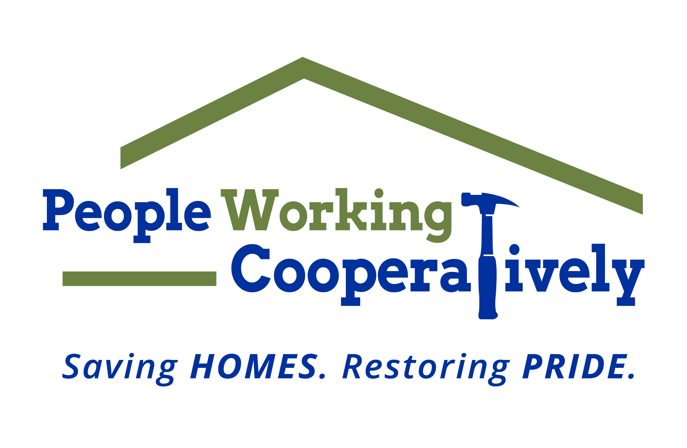
Media Contact: Jamie Glavic, Scooter Media
(859) 409-9943 | jamie@scootermediaco.com

FOR IMMEDIATE RELEASE

People Working Cooperatively’s Whole Home Innovation Center
Launches New Safe & Healthy at Home Series

Cincinnati, OH (July 13, 2020) – People Working Cooperatively’s (PWC) Whole Home Innovation Center is launching a new series designed to help seniors and caregivers stay safe and healthy at home. The program, rooted in falls awareness and prevention training strategies, is free and available in-person and online thanks to a partnership with the City of Cincinnati. Participants will meet two hours a week for five weeks. To ensure safe social distancing, on-site classes are limited to four registrants. Online workshops can support up to 20 participants per session. Registration is available at wholehome.org/events.

The series schedule is:

Saturday, July 18 – August 15 | 10 am - Noon
Tuesdays, July 21 – August 18| 10 am – Noon or 1:30 – 3:30 pm
Thursdays, July 23 – August 20 | 10 am – Noon

“Home is where we are safest, even more so for seniors who live independently,” said Nina Creech, Whole Home Senior Vice President of Operations. “It’s proven that falls prevention programming saves lives and as we continue practice social distancing, we saw a need for a virtual program to connect with our clients from the comfort of their own homes.”

Whole Home’s Safe & Healthy at Home series will examine the relationship between home and health, empowerment and taking control of one’s health, eating, exercise, medication management and more. Each participant who completes the five-week program will also receive a complimentary home consultation for safety measures and recommendations by one of Whole Home’s healthy at home specialists. Participants must be residents of the City of Cincinnati.

To register, visit wholehome.org/events or for inquiries, email events@wholehome.org or call (513) 482-5100.

###

About People Working Cooperatively
Incorporated in 1975, People Working Cooperatively (PWC) is a non-profit organization serving low-income, elderly, and disabled homeowners in 18 counties of Greater Cincinnati, Dayton, Northern Kentucky and Indiana. PWC strengthens communities by providing professional, critical home repair, weatherization, modification and education services to help residents stay safely in their homes. In the last 45 years, PWC’s staff of licensed, trained employees and dedicated corps of 3,000 volunteers have assisted more than 320,000 individuals. For more information, visit pwchomerepairs.org or call (513) 351-7921.

