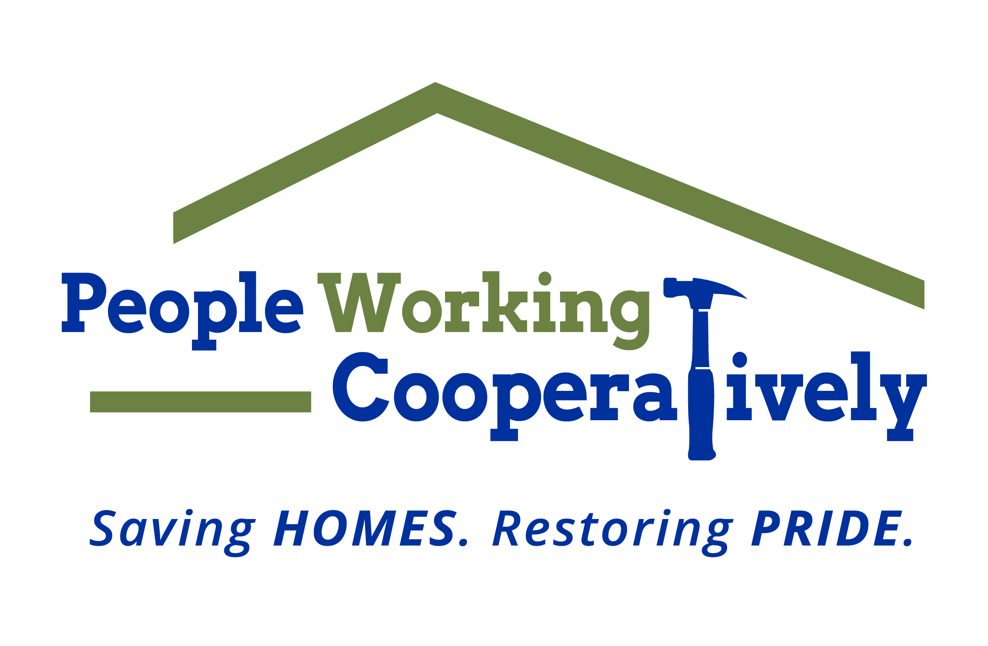
Media Contact: Jamie Glavic, Scooter Media
(859) 409-9943 | jamie@scootermediaco.com

FOR IMMEDIATE RELEASE

People Working Cooperatively Receives $275,000 in Grants
to Support Homeowners Impacted by COVID-19
Funding Supports Health and Safety Emergency Repairs

Cincinnati, OH (January 20, 2021) – People Working Cooperatively (PWC) has received $275,000 in grant funding from local organizations to support critical home repairs and modifications, service programs and more.

- $125,000 has been awarded by the CenterPoint Energy Foundation to support home repairs and modifications in the Dayton region;
- $50,000 has been awarded by the Truist Foundation for PWC technology upgrades;
- $30,000 has been awarded by the Sutphin Family Foundation for home repairs and modifications in Greater Cincinnati;
- $30,000 has been awarded by the Horizon Community Funds of Northern Kentucky for home repairs and modifications in Northern Kentucky;
- $20,000 has been awarded by the L&L Nippert Charitable Foundation to support PWC’s childhood asthma partnership program with Cincinnati Children’s Hospital; and
- $20,000 has been awarded by the Butler Foundation for home repairs and modifications in Northern Kentucky.

“We are grateful for these organizations, who believe in our mission and support our services and programs that benefit so many across the region,” said Chris Owens, Vice President of Development for People Working Cooperatively. “Every dollar is used to support our mission of keeping our neighbors in need safe and healthy in their homes.”

To learn more about People Working Cooperatively or to request a health and safety emergency repair, visit pwchomerepairs.org or call (513) 351-7921.

###

About People Working Cooperatively
Incorporated in 1975, People Working Cooperatively (PWC) is a non-profit organization serving low-income, elderly, and disabled homeowners in 19 counties of Greater Cincinnati, Dayton, Northern Kentucky and Indiana. PWC strengthens communities by providing professional, critical home repair, weatherization, and modification services to help residents stay safely in their homes. In the last 45 years, PWC’s staff of licensed, trained employees and dedicated corps of 3,000 volunteers have assisted more than 320,000 individuals. For more information, visit pwchomerepairs.org or call (513) 351-7921.

