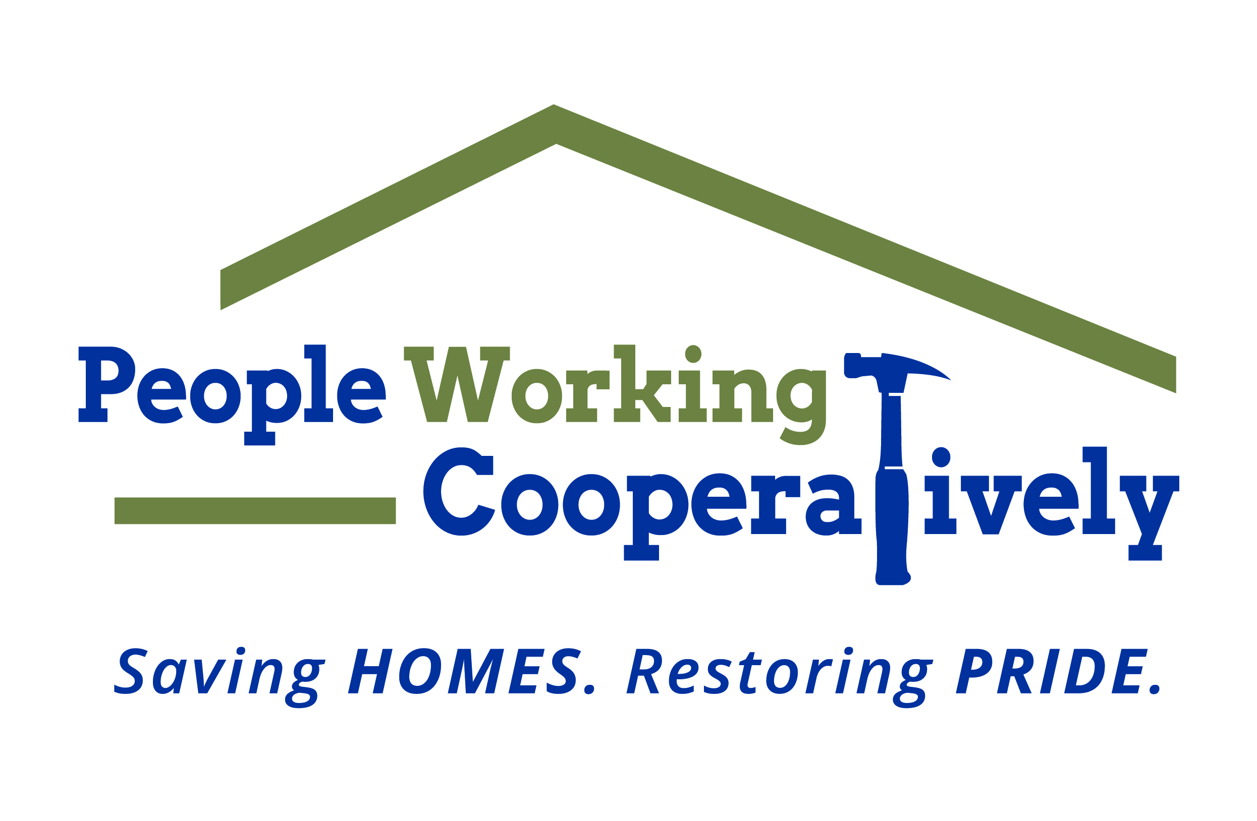
Media Contact: Jamie Glavic, Scooter Media
(859) 409-9943 | jamie@scootermediaco.com

FOR IMMEDIATE RELEASE

Whole Home Innovation Center Adds Physical Therapist to Staff

CINCINNATI – People Working Cooperatively’s Whole Home Innovation Center (WHIC) recently added Lisa Capannari to the team, furthering the organization’s mission of connecting health and home. Capannari is the first medical professional to join the organization, leading the falls prevention programming as Stepping On Instructor.

A graduate of the University of Cincinnati, Capannari has more than 33 years of physical therapy experience in both hospital and home health settings. She has also assisted with the delivery of TriHealth’s Think First Trauma Prevention program for school systems for more than 25 years.

In her new role as the Stepping On Instructor, Capannari will facilitate the organization’s falls prevention programming, including the popular “Stepping On” class series, which is an evidence-based program designed to prevent falls in older adults.

“We’re incredibly excited to add Lisa to the Whole Home team, and know that her experiences will be a valuable asset to the clients we serve,” said Nina Creech, Senior VP of Operations at PWC’s Whole Home Innovation Center.

Capannari lives on the west side of Cincinnati with her husband Joe.

To learn more about the Whole Home Innovation Center visit wholehome.org.

###

About People Working Cooperatively’s Whole Home Innovation Center
People Working Cooperatively's Whole Home Innovation Center provides critically needed services, ranging from repairs to safety improvements to educational programs, all aimed at keeping you safe and healthy at home. From Aging in Place partnerships and programming to healthcare collaborations, Whole Home is here to help. For more information, visit wholehome.org or call (513) 482-5100.

About People Working Cooperatively
Incorporated in 1975, People Working Cooperatively (PWC) is a non-profit organization serving low-income, elderly, and disabled homeowners in 19 counties of Greater Cincinnati, Dayton, Northern Kentucky and Indiana. PWC strengthens communities by providing professional, critical home repair, weatherization, and modification services to help residents stay safely in their homes. In the last 46 years, PWC’s staff of licensed, trained employees and dedicated corps of 3,000 volunteers have assisted more than 320,000 individuals. For more information, visit pwchomerepairs.org or call (513) 351-7921.

