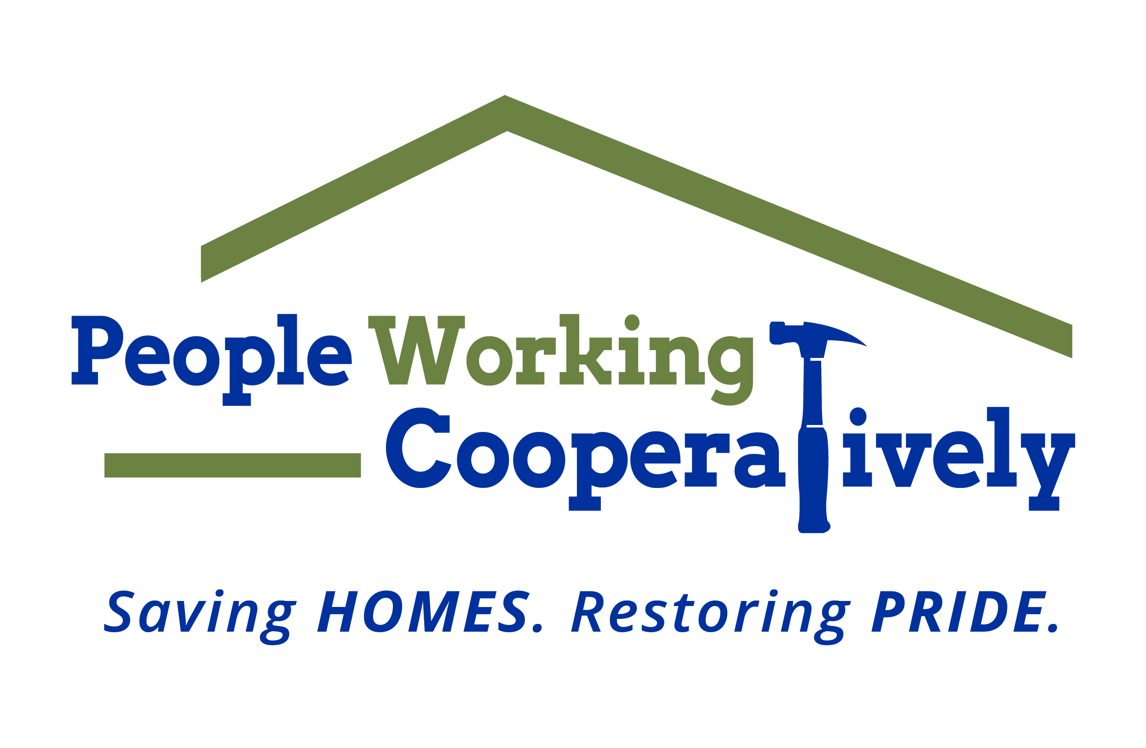
Media Contact: Jamie Glavic, Scooter Media
(859) 409-9943 | jamie@scootermediaco.com

FOR IMMEDIATE RELEASE

People Working Cooperatively Raises $180,500 During ToolBelt Ball Campaign
Funds Benefit the Organization’s “Modifications for Mobility” Program

CINCINNATI (June XX, 2021) – People Working Cooperatively’s (PWC) ToolBelt Ball may have been “Under Construction” in 2021, but thanks to the generosity of its supporters, the organization was still able to raise $180,500 to support the organization’s “Modifications for Mobility” program. Unable to host its annual fundraiser in person due to the lingering pandemic, PWC pivoted to an online campaign model spanning six weeks, with proceeds going to assist low-income, elderly homeowners and people with disabilities who have mobility limitations in the Tri-State area.

“Since the pandemic began, we’ve experienced a significant increase in service needs across the region,” said Jock Pitts, PWC President and CEO. “The generous support of our donors, partners and sponsors this spring allows us to continue serving those who need our help the most. The funds raised during this year’s ToolBelt Ball will allow us to assist 50 or more homeowners — and we look forward to being able to help even more once the “re-tooled” in-person ToolBelt Ball resumes next year.”

The services provided by PWC for these homeowners could include the construction of handicapped-accessible ramps, the installation of chair/stair lifts, and bathroom modifications that improved daily mobility and independence for clients across the region.

“This six-week campaign model was new for us, and we challenged our organization by setting a fundraising goal at $175,000,” said Chris Owens, PWC Vice President of Development. “We are incredibly thankful to the community for embracing our ‘Under Construction’ ToolBelt Ball campaign and more importantly, for helping our neighbors in need stay safe and healthy at home.”

This year’s top level corporate supporters included L3Harris at the Diamond Drill level; Citi, Duke Energy and Macy’s at the Golden Hammer level; and Fifth Third, Jacobs Engineering, NextStep Networking, PNC Bank, Recker and Boerger, Spectrum and Taft Law and Focused Capitol Solutions LLC at the Silver Saw level.

To learn more about People Working Cooperatively, visit pwchomerepairs.org.

###

About People Working Cooperatively
Incorporated in 1975, People Working Cooperatively (PWC) is a non-profit organization serving low-income, elderly, and disabled homeowners in 19 counties of Greater Cincinnati, Dayton, Northern Kentucky and Indiana. PWC strengthens communities by providing professional, critical home repair, weatherization, and modification services to help residents stay safely in their homes. In the last 46 years, PWC’s staff of licensed, trained employees and dedicated corps of more 3,000 volunteers have assisted more than 330,000 individuals. For more information, visit www.pwchomerepairs.org or call (513) 351-7921.

