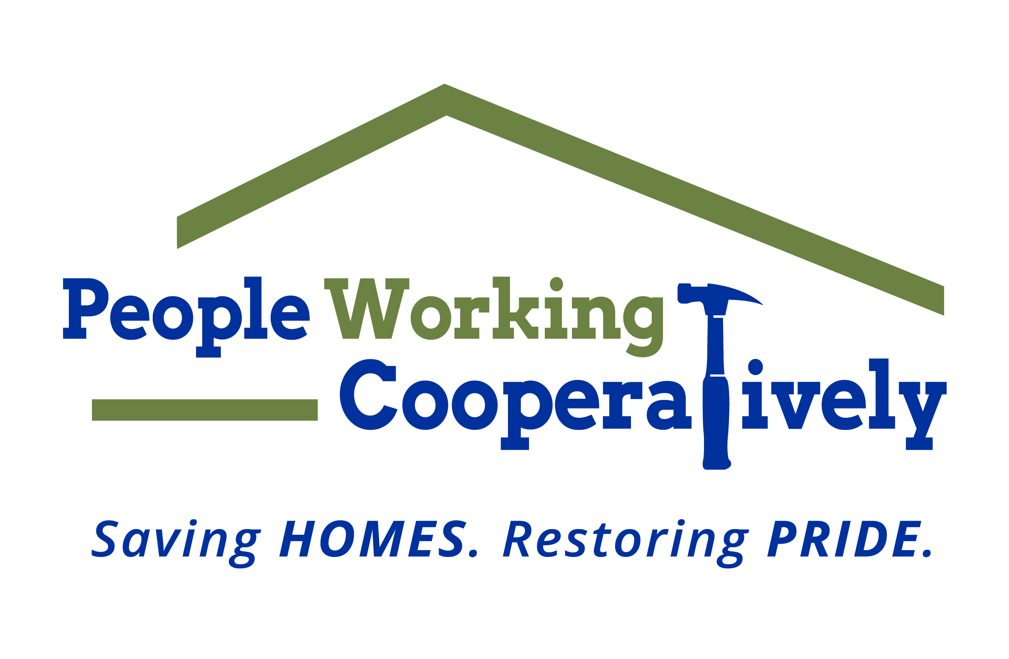
Media Contact: Jamie Glavic, Scooter Media
(859) 409-9943 | jamie@scootermediaco.com

FOR IMMEDIATE RELEASE

People Working Cooperatively (PWC) Receives $200,000 from The Home Depot Foundation for Veteran Home Repairs and Modifications in Greater Cincinnati

Cincinnati, OH (June 30, 2020) – People Working Cooperatively (PWC) has received a $200,000 grant from The Home Depot Foundation, which will be used to assist local veterans in need of critical home repairs and accessibility modifications to stay safely in their homes.

“We are grateful to The Home Depot Foundation for their continued support and dedication to the veteran community,” said Chris Owens, Vice President of Development at PWC. “Like Team Depot, PWC is committed to improving the homes and lives of veterans and their families, and these funds will make a substantial impact in the lives of veterans right here in our community.”

There are more than 9,000 veterans over the age of 65 living in poverty in the Tri-State, and nearly 300 veteran households are currently waiting for PWC services such as accessibility modifications and other critical home repairs. In the last four years, PWC has provided services for over 3,000 households of veterans or their surviving spouses.

To learn more about People Working Cooperatively, or to find out if you qualify for services, visit pwchomerepairs.org or call (513) 351-7921.

###

About People Working Cooperatively
Incorporated in 1975, People Working Cooperatively (PWC) is a non-profit organization serving low-income, elderly, and disabled homeowners in 18 counties of Greater Cincinnati, Dayton, Northern Kentucky and Indiana. PWC strengthens communities by providing professional, critical home repair, weatherization, and modification services to help residents stay safely in their homes. In the last 45 years, PWC’s staff of licensed, trained employees and dedicated corps of 3,000 volunteers have assisted more than 320,000 individuals. For more information, visit pwchomerepairs.org or call (513) 351-7921.

