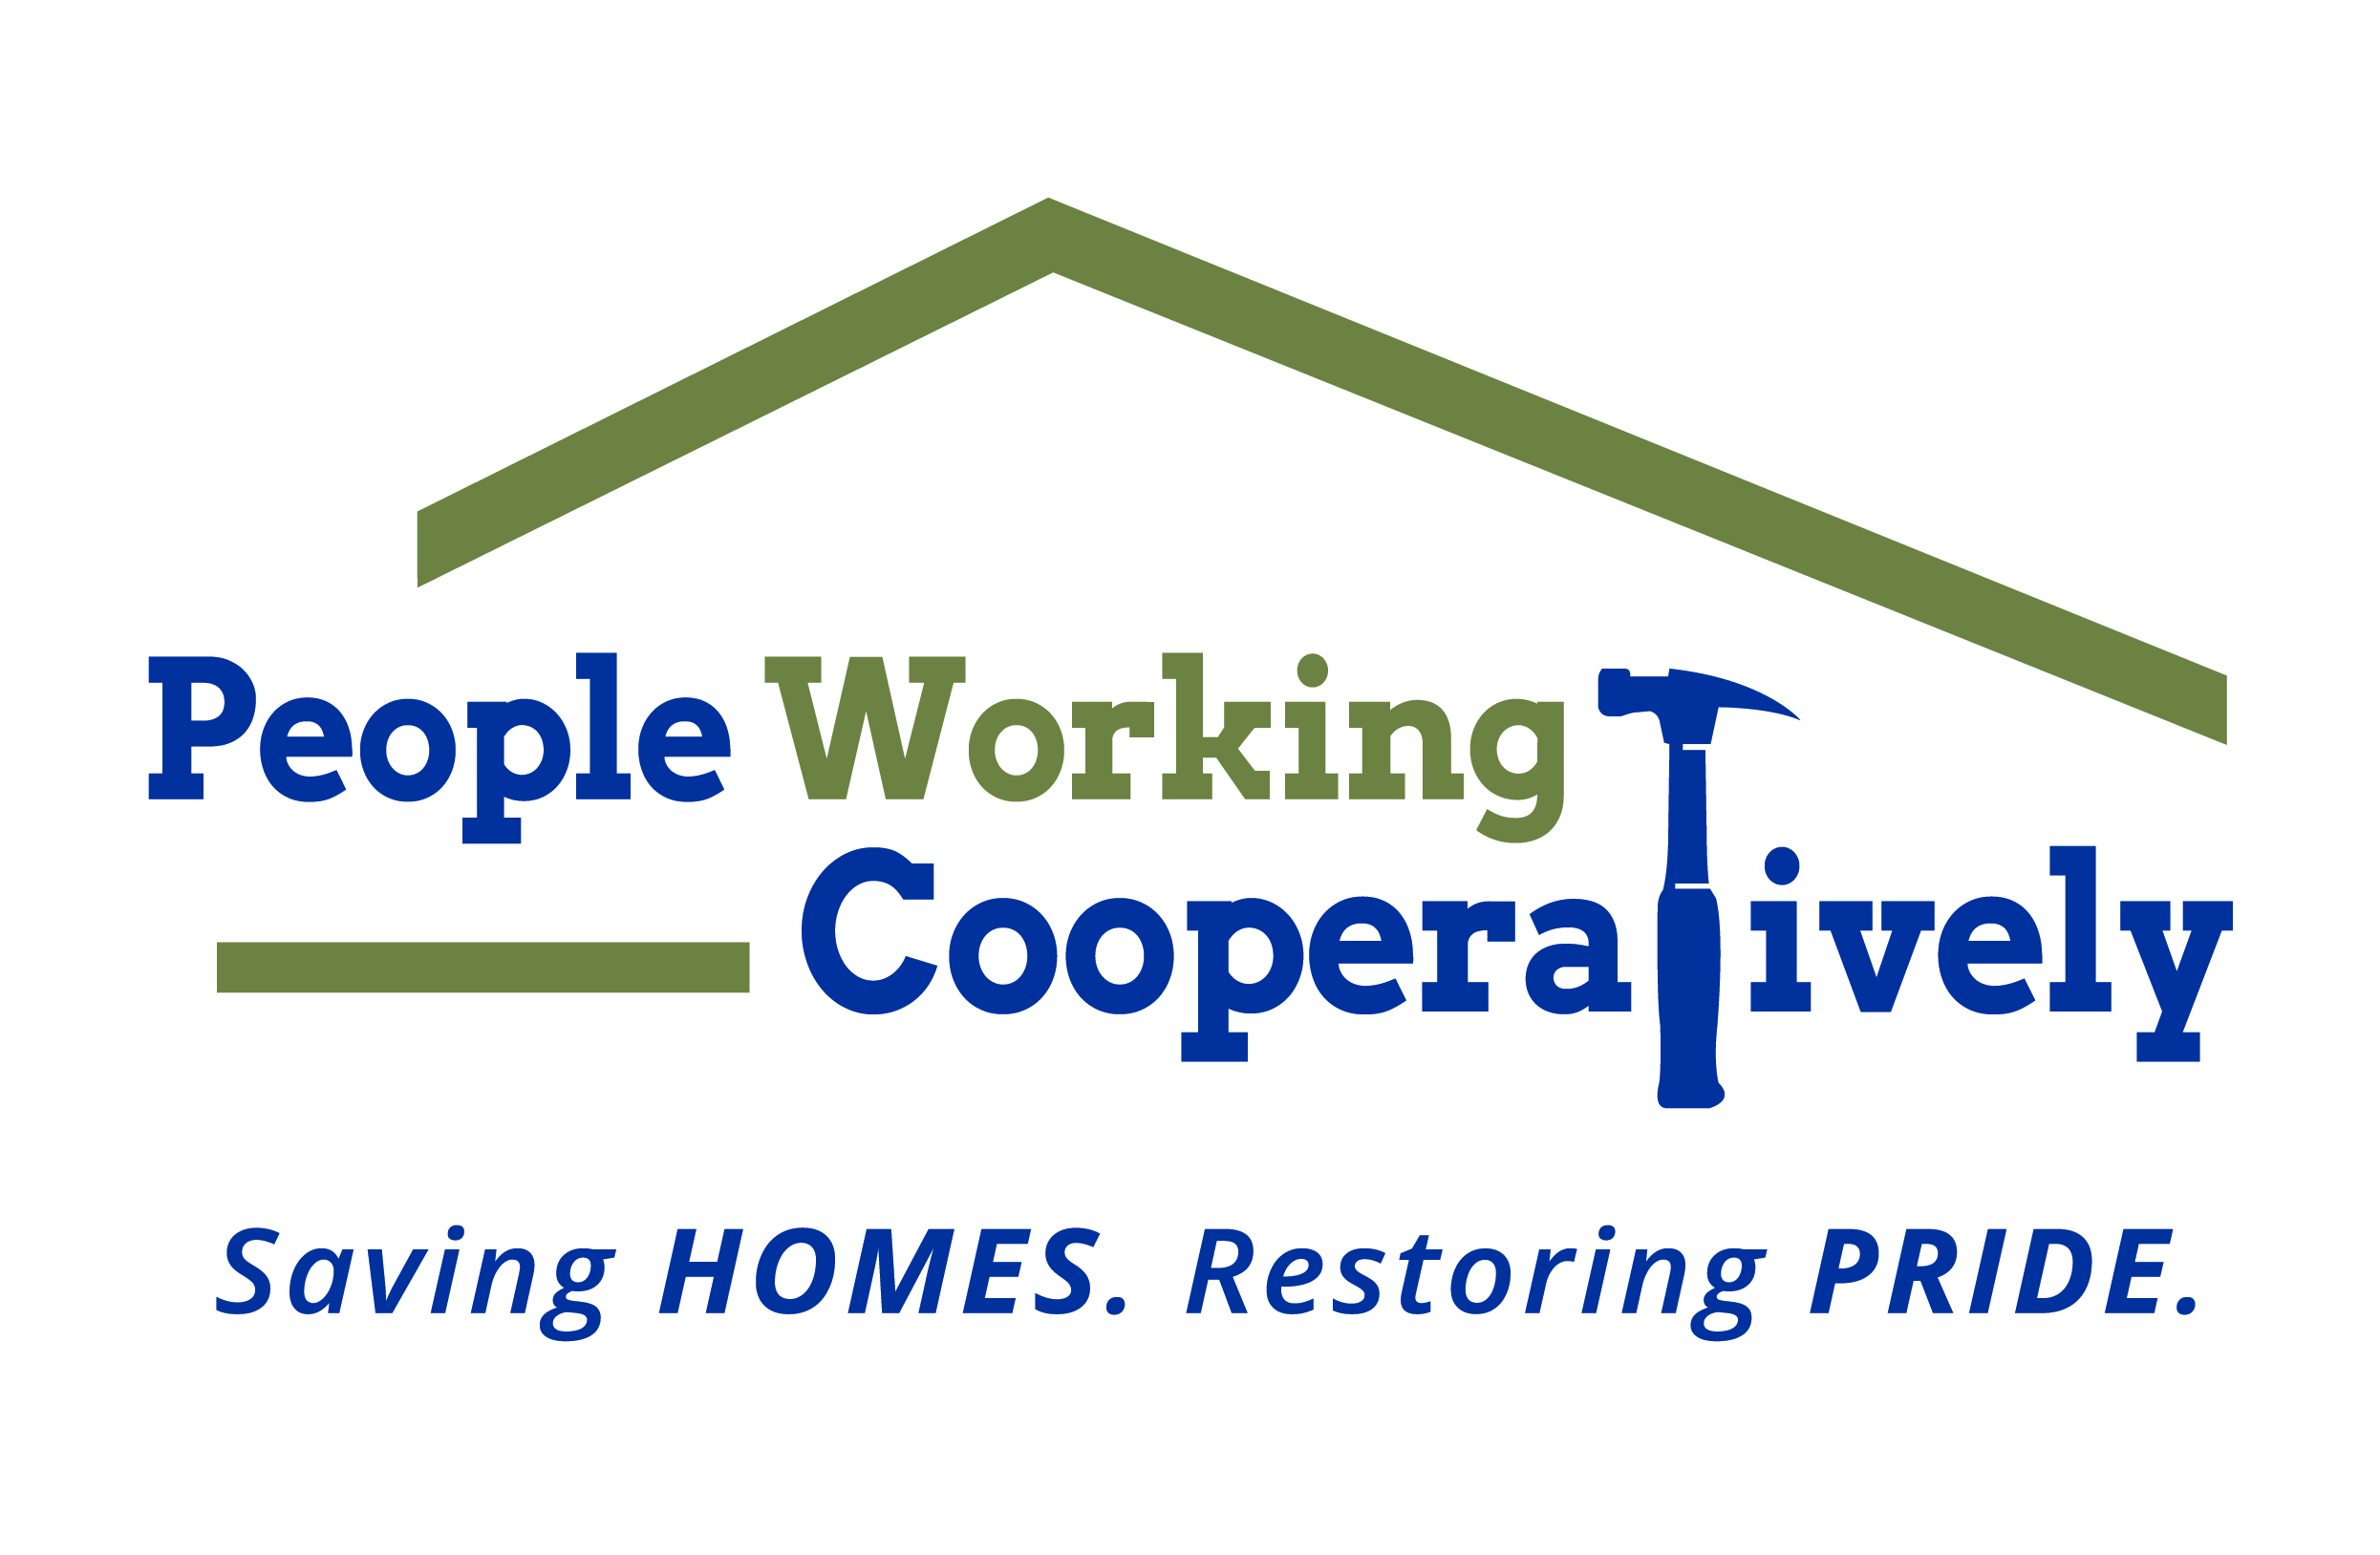
Media Contact: Jamie Glavic, Scooter Media
(859) 409-9943 | jamie@scootermediaco.com

FOR IMMEDIATE RELEASE

People Working Cooperatively Receives $175,000 in Grants
to Support Homeowners Impacted by COVID-19
Funding Supports Health and Safety Emergency Repairs

Cincinnati, OH (May XX, 2020) – People Working Cooperatively (PWC) has received $175,000 in grant funds to perform health and safety emergency repairs for individuals and families impacted by COVID-19.

- $100,000 has been awarded by the Greater Cincinnati Foundation; $50,000 to support Level 1 Emergency Services through its Safety Net Grant and $50,000 from the Greater Cincinnati Foundation and United Way of Greater Cincinnati’s COVID-19 Regional Response Fund Grant to support those impacted by COVID-19. Both awards cover emergency services in Boone, Butler, Campbell, Clermont, Dearborn, Hamilton, Kenton and Warren Counties.
- $50,000 has been awarded by the COVID-19 Regional Response Fund covering Hamilton, Butler and Warren Counties to provide health and safety emergency repairs for those impacted by COVID-19 in Warren County.
- $25,000 has been awarded by the Hamilton Community Foundation and the Butler County United Way’s COVID-19 Regional Response Fund Grant to support emergency repair services for those impacted by COVID-19 in Butler County.

These funds allow PWC to address time-sensitive, emergency repairs needed to help our neighbors in need stay safely in their homes as the region continues to combat the coronavirus pandemic. Health and safety emergency repairs are defined as issues that pose an immediate threat to the homeowner’s well-being, including:

- No heat
- No water
- Gas fumes present
- An electrical condition that poses a fire threat
- Accessibility modification to allow a client to return home
- First-floor doors or windows cannot be closed and/or secured
- Client’s only accessible commode is blocked or otherwise unusable
- Broken water lines where water is pouring, not dripping, out of the line
- Existing air conditioning is not working and a resident’s health issues could be complicated during a heat emergency
- Main drain/sewage backup

“We are thankful for the support we have received from these organizations, who have expedited the funding process to meet the immediate needs of our community during this unprecedented time,” said Jock Pitts, President and CEO of People Working Cooperatively. “With these funds, PWC will be able to address the emergency home repairs needed by our current client base, and to expand our reach to other neighbors in need who may not be familiar with our services.”

To learn more about People Working Cooperatively or to request a health and safety emergency repair, visit pwchomerepairs.org or call (513) 351-7921.

###

About People Working Cooperatively
Incorporated in 1975, People Working Cooperatively (PWC) is a non-profit organization serving low-income, elderly, and disabled homeowners in 20 counties of Greater Cincinnati, Dayton, Northern Kentucky and Indiana. PWC strengthens communities by providing professional, critical home repair, weatherization, and modification services to help residents stay safely in their homes. In the last 45 years, PWC’s staff of licensed, trained employees and dedicated corps of 3,000 volunteers have assisted more than 320,000 individuals. For more information, visit pwchomerepairs.org or call (513) 351-7921.

