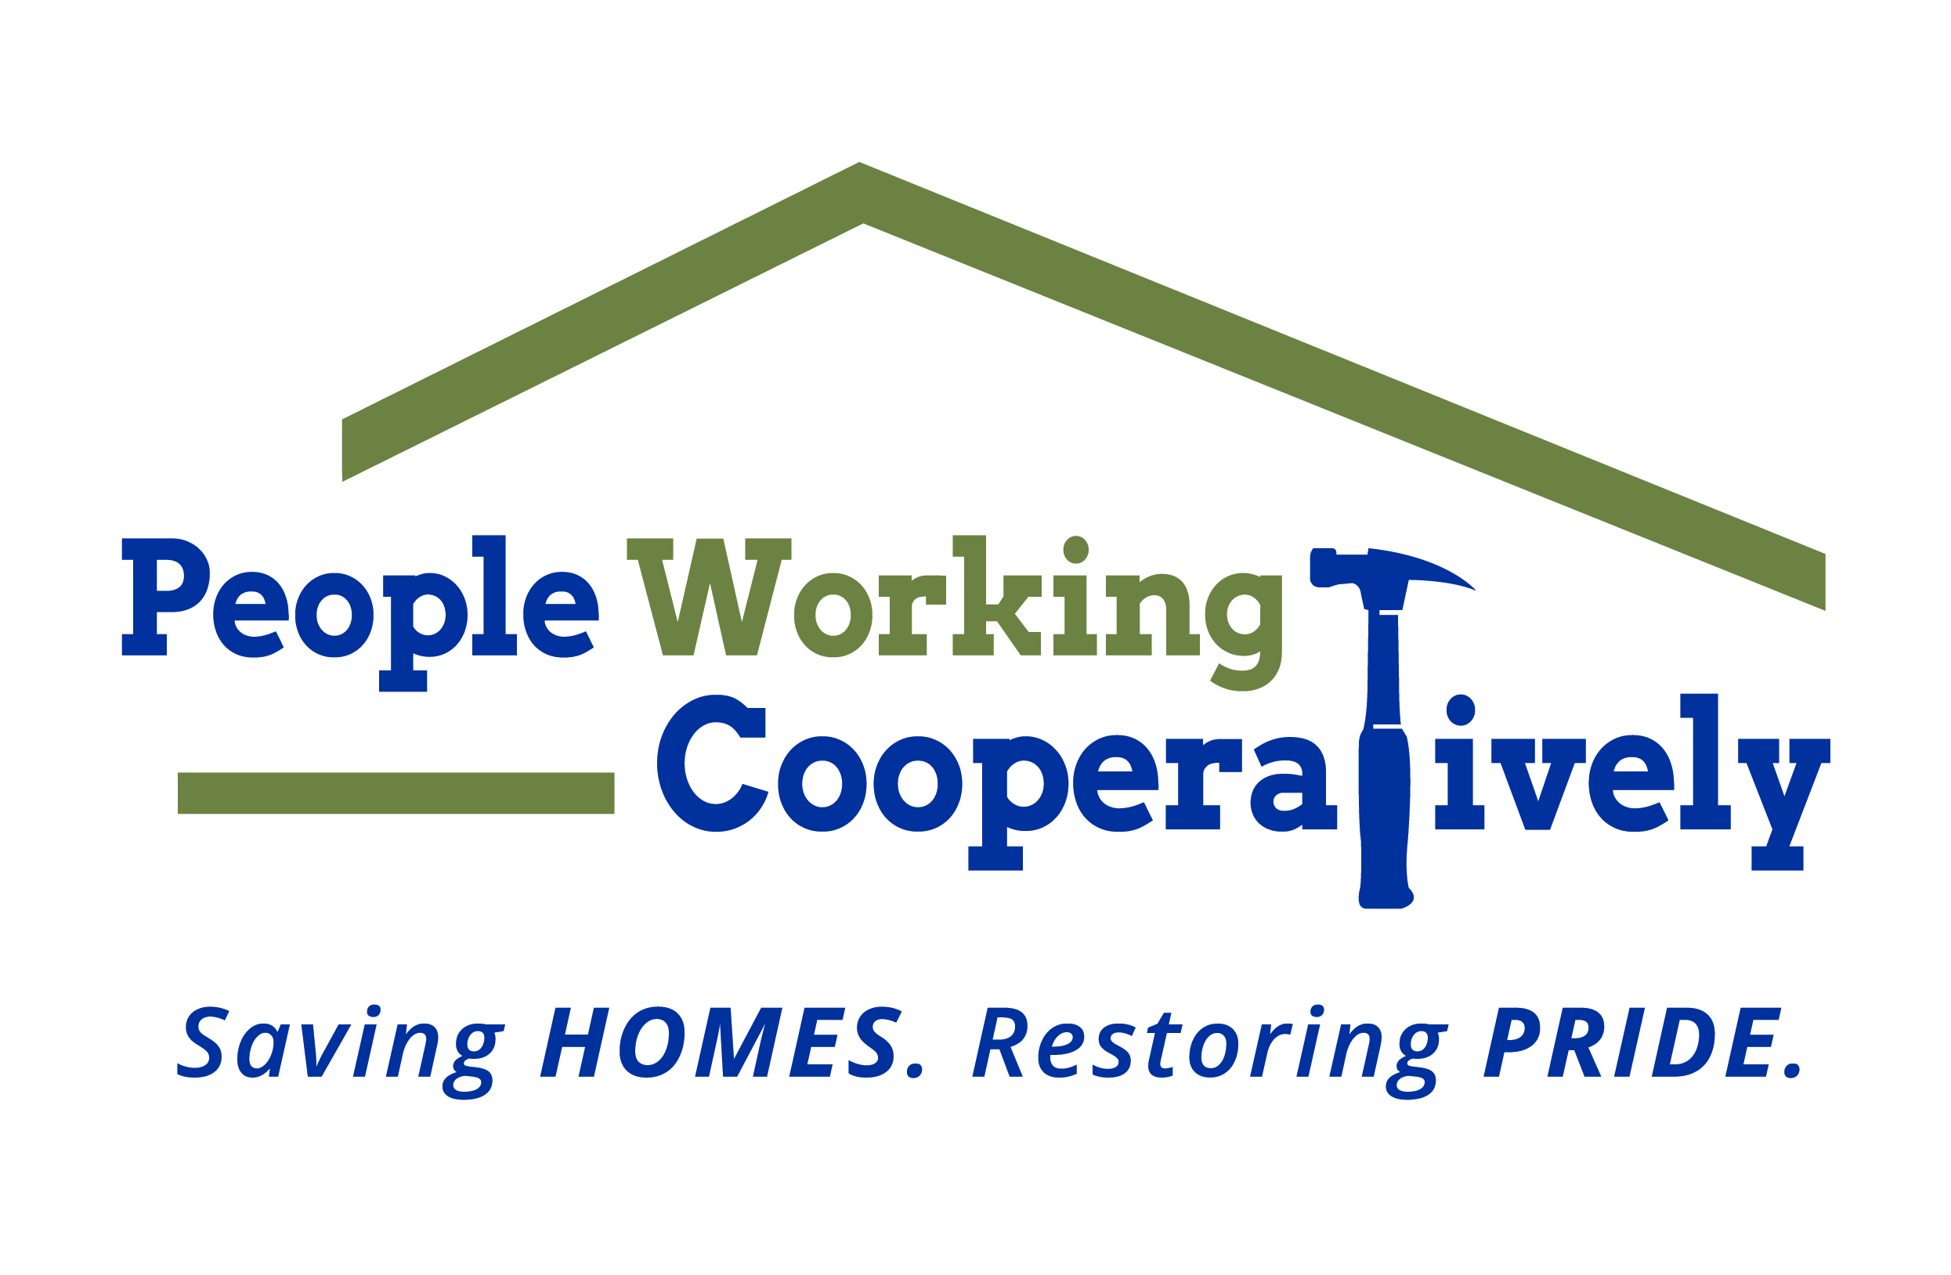
Media Contact: Jamie Glavic, Scooter Media
(859) 409-9943 | jamie@scootermediaco.com

FOR IMMEDIATE RELEASE

People Working Cooperatively Receives Funding Support from 7 Local Benefactors
Funding Supports Modifications, Service Programs and More

Cincinnati (July 31, 2020) – People Working Cooperatively (PWC) has received more than $80,000 in grant funding from local organizations to support critical home repairs and modifications, service programs and more.

- $30,000 has been awarded by the Charles H. Dater Foundation to support PWC’s student summer service program;
- $25,000 has been awarded by the U.S. Bank Foundation to support critical home repairs and modifications;
- $20,000 has been awarded by the Wohlgemuth Herschede Foundation to support critical home repairs and modifications;
- $5,000 has been awarded by the Integra Foundation to support PWC’s volunteer program;
- $1,000 has been awarded by Greater Cincinnati Foundation’s Summertime Kids fund to support summer youth volunteer services;
- $1,000 has been awarded by Mount St. Joseph University’s Student Philanthropy Program for personal protective equipment (PPE);
- SC Ministry Foundation has awarded grant funds to support Price Hill community revitalization.

“We are incredibly grateful for organizations that believe in our mission, many of whom have been long-term partners to PWC,” said Chris Owens, Vice President of Development for People Working Cooperatively. “Every dollar is used to support our mission of keeping our neighbors in need safe and healthy in their homes.”

To learn more about People Working Cooperatively or to find out if you are eligible for services, visit pwchomerepairs.org or call (513) 351-7921.

###

About People Working Cooperatively
Incorporated in 1975, People Working Cooperatively (PWC) is a non-profit organization serving low-income, elderly, and disabled homeowners Greater Cincinnati, Dayton, Northern Kentucky and Indiana. PWC strengthens communities by providing professional, critical home repair, weatherization, and modification services to help residents stay safely in their homes. In the last 45 years, PWC’s staff of licensed, trained employees and dedicated corps of 3,000 volunteers have assisted more than 320,000 individuals. For more information, visit pwchomerepairs.org or call (513) 351-7921.

