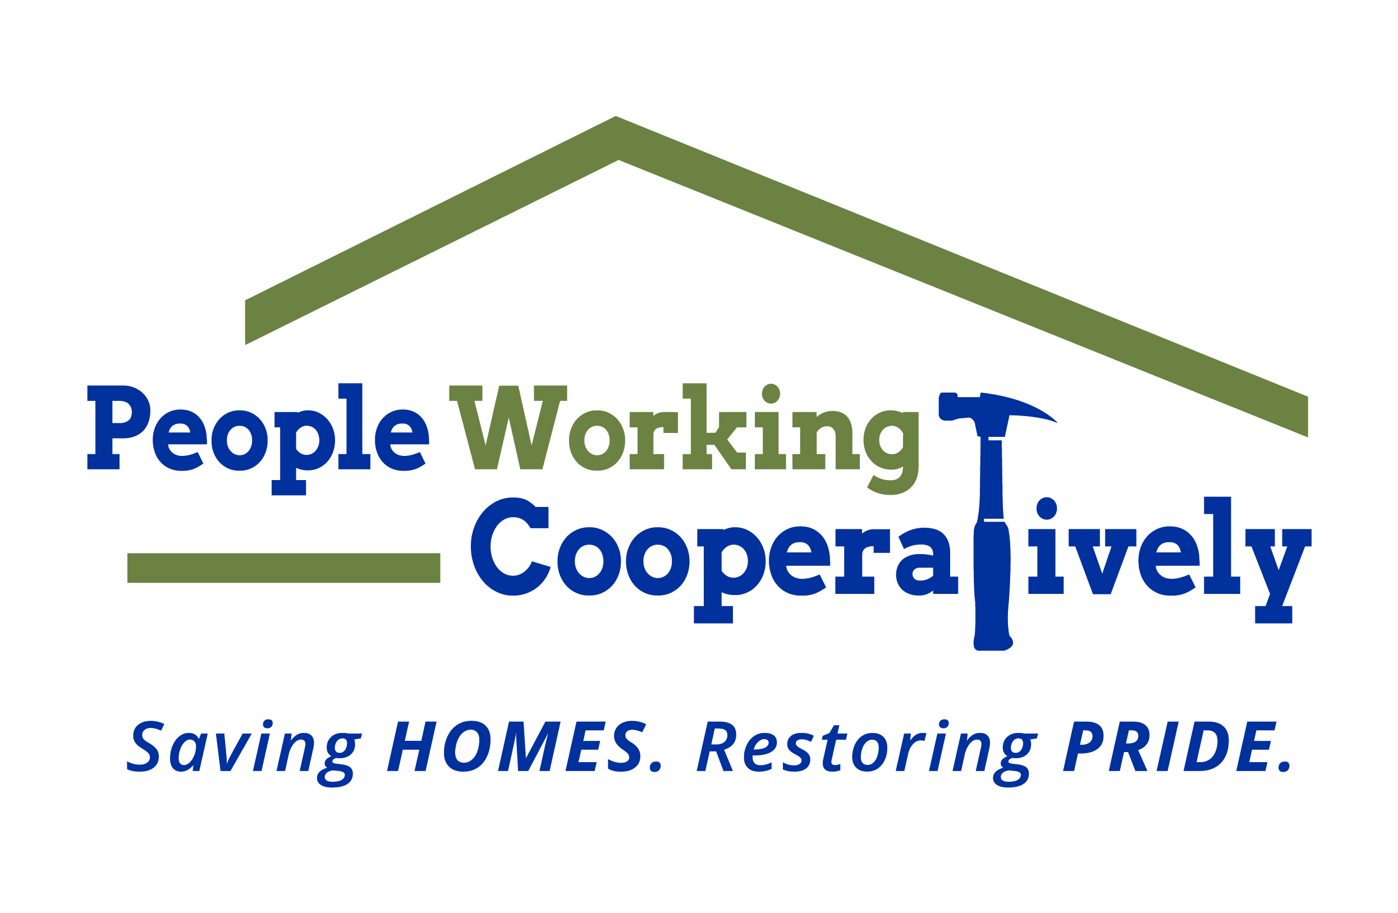
Media Contact: Jamie Glavic, Scooter Media
(859) 409-9943 | jamie@scootermediaco.com

FOR IMMEDIATE RELEASE

People Working Cooperatively Receives $25,000 Healthy Homes Grant

Cincinnati (September 16, 2020) – People Working Cooperatively (PWC) received $25,000 in grant funding from The P&G Fund of The Greater Cincinnati Foundation to provide home repairs, modifications and weatherization services to homeowners in need throughout the local community.

Thanks to the funds provided by this grant, PWC’s technicians were able to complete services for 38 individuals in 16 households across Cincinnati. Services ranged from electrical and HVAC tasks to plumbing and exterior work.

“The Healthy Homes award allowed our technicians to meet the needs of many clients on our waiting list, especially those in need of weatherization services,” said Chris Owens, Vice President of Development for People Working Cooperatively. “We’re glad to have the support of organizations like The P&G Fund of The Greater Cincinnati Foundation, which allows us to fulfill our mission of helping local neighbors in need stay safe and healthy in their own homes.

To learn more about People Working Cooperatively or to find out if you are eligible for services, visit pwchomerepairs.org or call (513) 351-7921.

###

About People Working Cooperatively
Incorporated in 1975, People Working Cooperatively (PWC) is a non-profit organization serving low-income, elderly, and disabled homeowners in 20 counties of Greater Cincinnati, Dayton, Northern Kentucky and Indiana. PWC strengthens communities by providing professional, critical home repair, weatherization, and modification services to help residents stay safely in their homes. In the last 45 years, PWC’s staff of licensed, trained employees and dedicated corps of 3,000 volunteers have assisted more than 320,000 individuals. For more information, visit pwchomerepairs.org or call (513) 351-7921.

