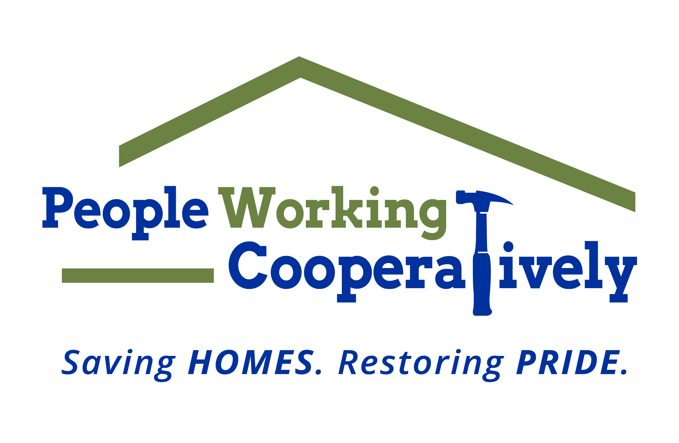
Media Contact: Jamie Glavic, Scooter Media
(859) 409-9943 | jamie@scootermediaco.com

FOR IMMEDIATE RELEASE

People Working Cooperatively Receives $50,000 Grant
from the Greater Cincinnati Foundation
Funding Supports Level 1 Emergency Home Repair Services

Cincinnati, OH (April 1, 2020) – People Working Cooperatively (PWC) announced today that it has been awarded a $50,000 grant from the Greater Cincinnati Foundation, providing a safety net for individuals and families to support Level 1 Emergency Home Repair Services. The funds will allow PWC’s trained technicians to address time-sensitive, emergency repairs needed to help the region’s most vulnerable stay safely in their homes. PWC has temporarily suspended non-emergency services in accordance with the orders and guidelines set forth by local, state, and federal public health officials.

“The vulnerable populations we serve daily are scared and anxious about the new health and financial hardships they are facing,” said Jock Pitts, President and CEO of People Working Cooperatively. “At this unprecedented time of crisis, our work of providing Level 1 Emergency Services is needed more than ever to ensure the safety and health of our low-income neighbors, including families with young children, seniors, people with disabilities, and other at-risk populations.”

Level 1 Emergencies are defined as issues that pose an immediate threat to the homeowner’s well-being, including:
- No heat
- No water
- Gas fumes present
- An electrical condition that poses a fire threat
- Accessibility modification to allow a client to return home
- First-floor doors or windows cannot be closed and/or secured
- Client’s only accessible commode is blocked or otherwise unusable
- Broken water lines where water is pouring, not dripping, out of the line
- Existing air conditioning is not working and a resident’s health issues could be complicated during a heat emergency
- Main drain/sewage backup

PWC has approval from the Ohio Homeland Security office and is authorized to provide these essential services under Governor Mike DeWine’s stay-at-home order.

To learn more about People Working Cooperatively or to report a Level 1 Emergency, visit pwchomerepairs.org or call (513) 351-7921.

###

About People Working Cooperatively
Incorporated in 1975, People Working Cooperatively (PWC) is a non-profit organization serving low-income, elderly, and disabled homeowners in 20 counties of Greater Cincinnati, Dayton, Northern Kentucky and Indiana. PWC strengthens communities by providing professional, critical home repair, weatherization, and modification services to help residents stay safely in their homes. In the last 45 years, PWC’s staff of licensed, trained employees and dedicated corps of 3,000 volunteers have assisted more than 320,000 individuals. For more information, visit pwchomerepairs.org or call (513) 351-7921.

